|  |
| --- |
| University of reading |
| Individual Project Report – Virtual Campus |
|  |

|  |
| --- |
| James Tang – 24015209 – xr015209 |



Student: James Tang

Student Number: 24015209

Supervisor: Timothy Threadgold

Submission Date: 19THApril 2018

Word Count: 11698

**Virtual Tour of Whiteknights Campus for Android Virtual Reality**

School of Mathematical, Physical and Computational Sciences

Individual Project – CS3IP16

# Abstract

This report discusses in detail about the creation of my Final Year Individual Project, Virtual Campus. Virtual Campus is a Virtual Reality version of University of Reading’s WhiteKnights Campus. The Virtual Tour of Whiteknights Campus is an Android application, which allows users to explore a part of Whiteknights campus using a teleportation based movement. The campus has been built using unity and runs on Nougat Android phones or higher. The android application has been built using Unity and the models of the building was created using SketchUp and users are free to explore a part of WhiteKnights campus. The aim of the Virtual Tour of WhiteKnights Campus is to allow users freely explore campus in a virtual reality setting, this also helps users who wish to come to University of Reading but may be unable to attend an open day, so they can download this app and then explore campus in Virtual Reality.

# Acknowledgements

I would like to personally thank Timothy Threadgold for his support and suggestions for my project. Without his help, half of the implementations in this project wouldn’t be possible without him. His assistance has been supportive and assisted lead the project into the right way.

I would also like to personally thank my mentor Gary Edwards for his continued support and mentoring on my wellbeing. Without his support, this project may have never been completed or been completed but not in the way I wanted it to be.

# Table of Contents

Abstract 3

Acknowledgements 3

Table of Contents 4

Glossary of Terms & Abbreviations 6

1. – Introduction 7

2. – Problem Articulation and Objectives 8

2.1 – Stakeholders 8

2.2 – Objectives 8

3. – Literature Review / Initial Research 10

3.1 – Platforms for virtual reality 10

3.2 – Programs used to build the virtual campus 11

3.2.1 – Initial Research 11

3.2.2 – Virtual Reality Applications 11

3.2.3 – 3D Modelling 12

3.3 – Teleportation/Movement 13

3.3.1 – Initial research 13

3.3.2 – Teleport based movements (Or blink teleportation) 14

3.3.3 – Free movement 14

3.3.4 – Waypoint movement 15

4. – Technical Specification 16

4.6 – Constraints and Assumptions 17

5. – Solution Approach 18

5.1 – Program to build the virtual campus 18

5.2 – Program to build the models of the buildings 18

5.3 – Platform the Virtual Campus will run on 18

5.4 – Movement based/feel of the app 20

5.5 – Conclusion 21

6. – Design 23

6.1 – Start-up/User interface 23

6.2 – Camera Control Scheme 23

6.3 – Movement 24

7. – Implementation 25

7.1 – Campus Ground design 25

7.2 – Building design 27

7.3 – Adding buttons to the buildings for narration 28

7.4 – Movement 30

7.5 – Camera control 31

8. – Testing 32

9. – Discussion 32

10. – Social, Legal, Health & Safety & Ethical Issues 32

11. – Conclusion and Future Improvements 32

12. – Reflection 33

13. – Appendices 34

13.1 – Project Initiation Document 34

13.2 – Project Log Book 46

13.4 – Script for buildings 59

13.5 – Map of WhiteKnights Campus 59

13.6 – GitHub Repository Link 59

14. – References 60

Works Cited 60

14.2 – Assets used for the project 61

# Glossary of Terms & Abbreviations

APK – Android Package Kit

API – Application Programming Interface

FOV – Field of View

GPU – Graphics Processing Unit

GUI – Graphical User Interface

SKD – Software development kit

PC – Personal Computer

PID – Project Initiation Document

VR – Virtual Reality

# 1. – Introduction

Virtual Reality has been on the arise of popularity ever since 2010s when Palmer Luckey designed the first prototype of the virtual reality headset called the Oculus Rift. Two years later in 2015, video game developer and digital distribution company, Valve Corporation and consumer electronics company HTC, announced their virtual reality headset named HTC Vive. It featured controllers that allowed the user to interreact with the virtual environment. [1]

Today, Virtual Reality is possible and nearly accessible to anyone who possesses the latest model of a smartphone such as the iPhone or an Android phone (Like the Pixel or Samsung Galaxy) or own a console such as having a PS4 [2]. Virtual Reality headsets are becoming cheaper in general as well, so meaning that virtual reality is becoming more accessible to the public and thus increasing the popularity. [3]

The project is about creating a virtual reality version of WhiteKnights Campus, the application will be created primarily in Unity and all the buildings featured inside the WhiteKnights campus was made using SketchUp, the virtual campus application will be made for Android Devices running nougat or higher and have daydream/cardboard installed on it (The virtual reality software). The aims of the virtual reality campus are Provide users with a comfortable experience of Virtual Reality (Allowing to explore campus at their own pace), learn about the history of each building in WhiteKnights Campus. The App itself should be able to be installed on all phones running Android Nougat or higher and should provide smooth framerates and response no matter the hardware.

The personal motivation to pursue this project is explore and develop skills about virtual reality and how the public can benefit from using Virtual Reality to discover new worlds and experiences that might not be possible in real life. Virtual Reality can be used provide learning skills as it can be used as a training tool for example, using Virtual Reality to explore the human body for the medical sector or travel industry using virtual reality to encourage customers to buy holiday packages. [4] [5]

This report will discuss in detail about the creation of the application, the research made to prefect the Application, the approaches and implementations to create the project. The testing of the project along with its results. This report will also talk about the potential social, legal, ethical and health & safety issues that the project will have. Finally, this report will discuss the personal reflection and outcomes of the project.

# 2. – Problem Articulation and Objectives

The problem this project is addressing is many potential students in Sixth Forms/Colleges or postgraduate students may wish to study at University of Reading, however it is a possibility that they are unable to come to an open day, it could be for a variety of reasons ranging from; it could be too far away from them, they couldn’t afford travel to campus, they may be unavailable on the open day for example. Outside users may wish to visit the campus in general to see what it looks like. With virtual reality, it is possible that users can see what campus looks like virtually without them needing to be physically there, it may feel artificial but it should be a good substitute.

This project attempts to address the issue by creating a virtual reality version of Whiteknights campus which users can freely explore around a part of Whiteknights campus by using a ‘blink teleport’ feature where the user points by holding down a button to show an indicator to be teleported to the location specified by the user and then letting go once the user has chosen a location to be instantly teleported to that location. The user can also listen to voiced narration about the building that they are currently near, about what the building is and the history of the building.

The project was made using Unity and all buildings featured inside the campus was made using SketchUp. To create the virtual reality programming of the campus, a google cardboard/daydream SDK was used for allowing virtual reality to be enabled inside the project [6]. This project is made people using Android devices running Nougat (Android version 7.0) or higher with Daydream/cardboard installed (The software the android uses for virtual reality). The reason why I choose android devices instead of using Computer or Apple devices, is because Android devices are cheaper for virtual reality as most android devices today meet the suitable specifications for virtual reality [7]. This also helps University of Reading open days members who may wish to bring the virtual reality campus to open days on other schools or colleges because it would be easier to bring a smartphone with a virtual reality headset rather than carrying a computer/laptop with a headset.

## 2.1 – Stakeholders

The stakeholders that were identified of this project during development are: The first stakeholder is myself, as I am responsible for the development of the Virtual Campus application throughout the project’s development life cycle. The second stakeholder is my project manager, Timothy Threadgold who aided and recommended features that the project should have in terms of tools for aiding virtual reality creation and quality of life changes to the end user. Finally, the final stakeholder of the project is the end user, which is any potential student who owns an android device and wishes to study at the University of Reading who maybe is unable to attend an open day for a variety of reasons.

## 2.2 – Objectives

The primary objectives of the project will have to fulfil to meet the following technical specifications are:

* Provide users with a comfortable experience of Virtual Reality (Allowing to explore campus at their own pace).
* Learn about the history/backstory of each building in WhiteKnights Campus.
* The App itself should be able to be installed on all phones running Android Nougat or higher and should provide smooth framerates and response no matter the hardware.
* The app should have minimum bugs so provide a comfortable and realistic experience of the virtual reality application.
* Being able to explore most of WhiteKnights Campus.
* The application should be easy to use and users should have no problems trying to learn what to do and how to move around the virtual campus.

In summary completing these objectives will allow for an immersive experience in WhiteKnights campus and may persuade potential students to come to study at the University of Reading. The primarily aim of the Virtual Campus Application is for users to enjoy an immersive experience of WhiteKnights Campus, without any hassle or discomfort from the moment they install the application/try it out on an open day.

# 3. – Literature Review / Initial Research

For the project to be created to the best potential, research was made on this project beforehand. The research topics that was scoped out for virtual reality are; which platforms (Such as, PC, Mobile devices or consoles) has virtual reality and what platform the virtual campus will run on, the programs that would be using to build the virtual campus and finally user comfort in virtual reality, this topic is mostly about the types of teleports and what teleport will be used.

## 3.1 – Platforms for virtual reality

To begin the project, research was made on which platforms has virtual reality compatibility and which virtual reality platforms that has the most users on. First, I looked at the available platforms that have virtual reality compatibility. I found out through research [3] [8] that smartphones such as the Android Devices with Nougat or Higher (Android Software version 7.0 or higher) will have Daydream/Cardboard installed in most cases, the latest smartphones such as Samsung Galaxy series (S8) or Google Pixel. Apple devices will also have virtual reality like android’s. Smartphone for virtual reality are normally the cheapest and easiest to set up out of the other virtual reality devices. However, it comes at a cost of being the least immersive out of the others as most smartphone virtual reality devices offer the user to look around and move, whereas other virtual devices (such as the oculus rift or the HTC Vive) allow for interactivity in the virtual environment.

Another device that is virtual reality compatible is PCs. Personal Computers allow users to run a more detailed and interactive virtual reality providing that the user has a high-end computer (For example the user would typically need an Nvidia GTX 1060 Graphics Card or higher, an intel Core i5 CPU or higher and 8GBs of RAM or higher, to meet the recommend specifications according to Nvidia [9]) along with a compatible headset which are either the Oculus rift or the HTC Vive Headset. While Personal computers allow for the most interactivity between the user and the virtual environment, it comes at a cost of price as having a computer that meets the recommended specifications for virtual reality can cost more than £1500 as well as the cost of purchasing a virtual reality headset (Oculus rift normally costs £399 and HTC Vive normally costs £499). Also, users must have a decent sized room to get the most out of their virtual reality headsets as most virtual reality games will require the user to move the room around a lot.

Another alternative for paying virtual reality is paying for a PlayStation 4 Virtual Reality Headset which has it installed while it is cheaper than purchasing a PC (£349.99 for the headset along with £349.99 for the PS4 Pro which makes it around £700). The difference between the PlayStation VR and PC, is that PC allows for users to quickly build and publish virtual reality applications for Computers compared to PlayStation, as you build a Virtual Reality Application using Unity for example and you can quickly build it and run it on a virtual reality headset compared to waiting for approval from Sony to allow access on the PlayStation.

The other side of the research of deciding what platform the virtual campus will run on is deciding what platform of virtual reality has the most users on according to this research done by Felix Richter back in 2015 [10], is that most users have heard of Oculus Rift (35% of people), Samsung Gear VR (32% of people) and Google Cardboard (25% of people), while this statistic shows that people know more about oculus rift, Samsung Gear VR and Google Cardboard are more focused on smartphone virtual reality, showing that Smartphone Virtual Reality is the more popular platform than the PC market, mostly because it is cheaper and most people would purchase a smartphone than a PC as well, mostly for the convenience that smartphones bring compared to a Computer.

## 3.2 – Programs used to build the virtual campus

### 3.2.1 – Initial Research

To begin building the virtual campus I began research on programs that was suggested by my supervisor as well as own personal research. There are two types of programs that I must research, one for building the virtual reality application and one for modelling the buildings and other 3D models that may needed modelling. The programs my supervisor suggested to me were, Unity, Sketchup and Blender.

### 3.2.2 – Virtual Reality Applications

##### 3.2.2.1 – Unity

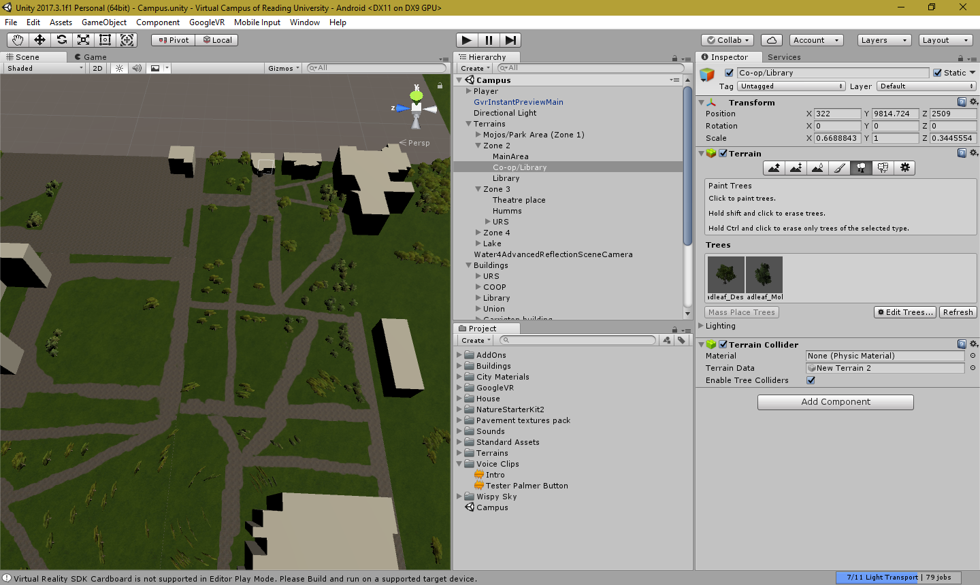

Figure 1 Screenshot of unity

The first program I have tested out was Unity, to see if it is suitable for helping me creating the main virtual reality program itself. I have never tried Unity before however it provides an easy to use tutorial and allows the user to understand the basics. The user interface is very simple to use and allows for tasks inside the program to be completed quicker.

Unity allows for Virtual Reality Support for most devices and implementation of the virtual reality SDK (Software Development Kit) provided by Google themselves [11] were easy to install and set up. Allowing for virtual reality to be enabled inside the project within an hour of installing it after following tutorials.

### 3.2.3 – 3D Modelling

##### 3.2.3.1 – Sketchup

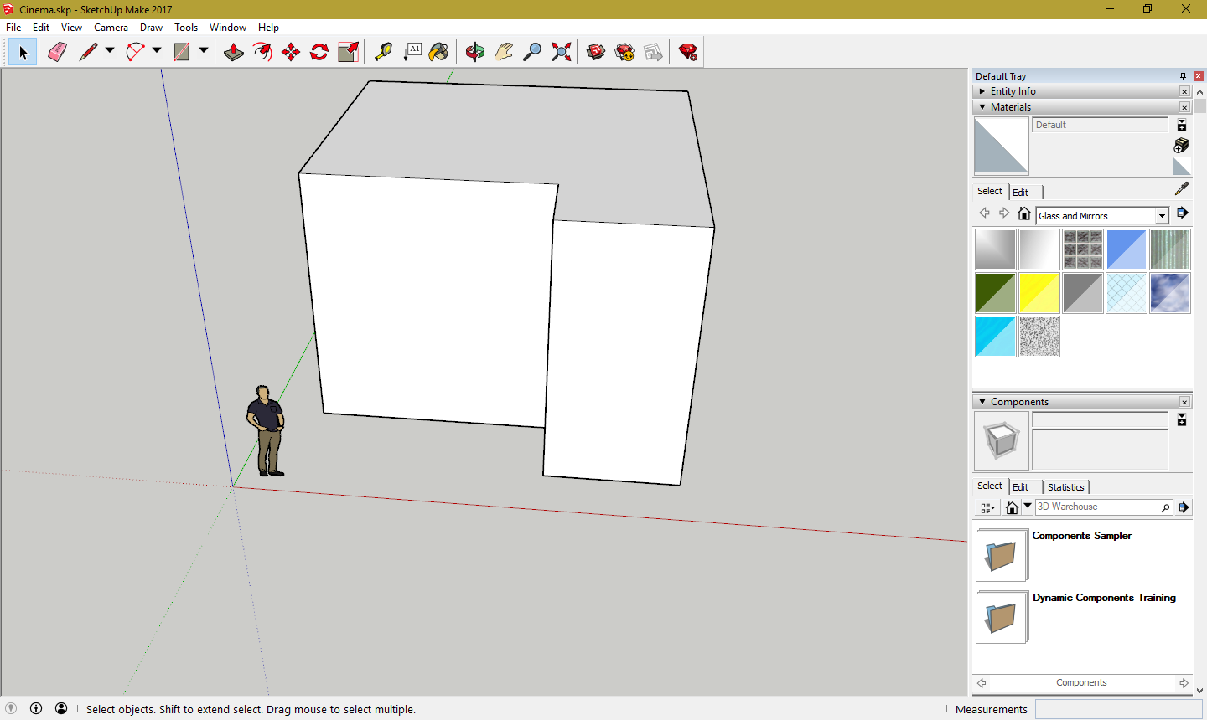

Figure 2 Screenshot of SketchUp

I have tested out SketchUp, to see if it is suitable for helping me create my models. I was familiar with SketchUp before, but I decided to test the program again, SketchUp Allows for easier building creation compared to blender, as it allows to create buildings via sculping where you draw an outline of the building and then you use the pull function to generate an 3D version of the outline of the building, I decided to use SketchUp for building generation as it allows for easy building creation and texturing.

##### 3.2.3.2 – Blender

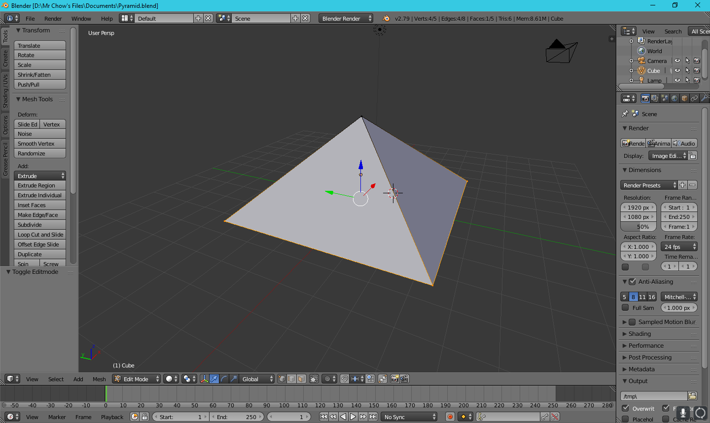

Figure 3 Screenshot of Blender

Blender is a free and open source 3D Modelling program, which allows users to sculp 3D models from a variety of shapes. For example, a building can be built by sculping it from a cube model, more complex models and be made with precise tools that Blender offers in the Edit model. While Blender offers more complex models than SketchUp however it is quite difficult to learn at first compared to SketchUp and the tasks to do in Blender take longer compared to SketchUp.

## 3.3 – Teleportation/Movement

### 3.3.1 – Initial research

To allow users to move around the campus, research was done on the types of movements that was possible in virtual reality. For each movement type researched, there was consideration for each movement type. To choose the right movement type, it had to reach the right number of criteria’s, which were:

* User comfort – How comfortable will the user feel when using this movement type? The primarily concern is user feeling motion sickness when using this movement type.
* Freedom – How free is the user when they are moving around with this movement type? Can they move anywhere in the virtual environment or are they locked to certain points?
* Simplicity – How easy is it for the user to learn about this movement type? Do they need to look at something to move or will the application automatically do the movement for them?

After doing research from learning from applications found in the google play store and watching YouTube videos, the three movement types were researched and considered for being the main source of movement inside the virtual campus are:

1. Teleport based movement (Or blink teleportation)
2. Free movement
3. Waypoint movement

### 3.3.2 – Teleport based movements (Or blink teleportation)

Teleport based movements was the first movement that I researched after watching VR games that used this movement. Teleport based movement allows users to point at a location they wish to transport to via an indicator appearing. They press a button to instantly be teleported there after a blink animation (Which is where the screen turns black for a second), they can teleport to any place that they wanted granted they have permissions to do so.

This is one of the best movement types because allows users to freely move around the environment without users feeling locked into the environment as well as avoid feeling motion sickness from freely moving around the environment too much as to move.

User may have difficulty understanding how to move for the first time as there is no indicators on how to move around the virtual environment but with a tutorial this problem can be easily solved.

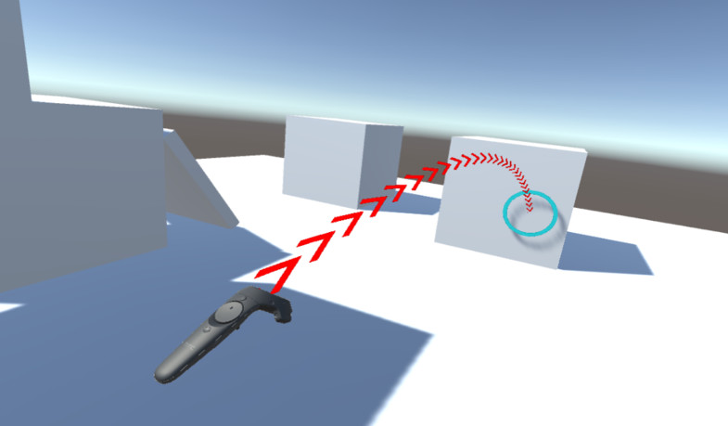

Figure 4 Screenshot of what teleportation in Virtual Reality look like, the user selects the place they wish to teleporter shown by normally the circle indicator – Photo Credit to: https://assetstore.unity.com/packages/3d/characters/vr-arc-teleporter-61561

### 3.3.3 – Free movement

Free movement allows users to move in a direction that they want, without needing to pause. This allows for the most realistic movement of virtual reality however it causes the most motion sickness as their eyes believe that they are moving however their body in real life isn’t. So, in the end, free movement will not be used for movement in the virtual campus, as not many people have been exposed to Virtual Reality and chances are most people will feel motion sickness upon using it for the first time. User may not know at first on how to correctly control themselves in virtual reality unless and tutorial is taught to them.

### 3.3.4 – Waypoint movement

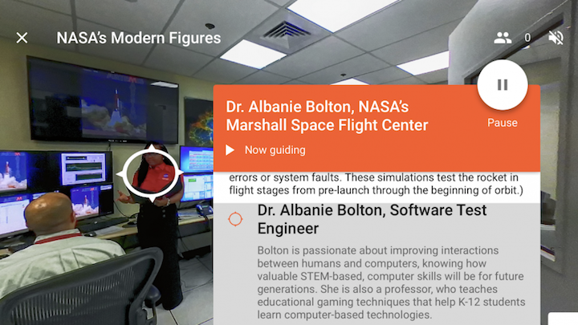

Figure 5 A screenshot of the android app, Google expeditions this allows users to view a 360-image using their virtual reality headsets. This allows the user to freely look around. The app allows for the user to know about the surrounding area by pressing nodes that are shown on the screen that displays more information when pressed.

Waypoint movement allows users to choose a node or a point on the screen, that the programmer specified and the user can look at the node and then press a button to be teleported to that node, in some cases, all the user must do is to press a button and they instantly jump to the next node. It allows the safest amount of moment for Virtual reality as compared to teleport based movement, users can potentially find errors and glitch by teleporting out of bounds by mistake, however it is the least restricted out of the three movement types are users are limited to moment by the nodes specified. It is also the simplest out of the three movement types as all the user needs to do is to press a button or to look at a node and press a button to teleport. In most cases there is no need for a tutorial as users will figure out on what to do.

# 4. – Technical Specification

For the technical specification, the technical objectives are written here, which are used for a guideline for the development of the project. The technical specification is split up into several parts. The technical specification is closely following the Project Initiation Document (PID)

##### 4.1 – Platform and Support

* The application should be able to run on all android devices that are running Nougat (Version 7.0) or higher and has daydream/cardboard installed on it or have Virtual Reality capabilities.
  + It is not possible to build the application for devices running lower than Nougat, it was considered, but since the size of the application and how much it objects that needed to be rendered at once. It was best for performance that it stays above Nougat or Higher to avoid performance issues on older devices.

##### 4.2 – GUI

* The user should be able to see all buttons on buildings to interact with them, the buttons will also have to be interactable and works as well.
  + Once the button has been pressed, the user should be able to hear about the backstory/history of the building.
* The user should see an indicator of where they are going to be teleported to once they pressed the button.
  + The user should be told by narration about how the movement scheme works.
* The user should see all the names of the buildings.

##### 4.3 – Rendering

* The user should be able to see a part of campus, the user will have a limited view of the campus to avoid performance issues (As rendering the entire map in one go on a phone may cause performance issues). The camera should render enough for the user can see where they are currently going.
* The user should be able to see the buildings and look around the buildings without rendering issues.
* The user should be able to explore and see the lake without performance issues.

##### 4.4 – Performance

* As noted above rendering. The performance should provide a comfortable experience by having at least a smooth framerate across all android devices, to avoid freezing or “lagging”, the rendering distance will be kept to a minimum to avoid performance issues.

##### 4.5 – General Goals

* The user should be able to explore a part of WhiteKnights campus and a part of WhiteKnights Lake at their own pace.
* The user should be able to hear all voiced narration when they press a button a building to hear the backstory/history of the building.
* The user should be able to see all the buildings rendered on the campus. The buildings will be created and textured using SketchUp.
* The application should have bugs to a minimum.
* The user should feel comfortable and not motion sick when using Virtual Reality for the first time and in general as well.
* The user should be able to explore all of campus without any problems such as collision errors or rending issues.

## 4.6 – Constraints and Assumptions

There are a lot of constraints and Assumptions in this project, these constraints and assumptions may hinder the project depending on the scenario.

##### 4.6.1 – Constraints

The following constraints are made for this project as follows:

* The entire campus will not be covered as it will too time consuming and the project won’t be finished before the deadline. So only the primarily the centre buildings will be covered.
  + This also counts for the other campus, London Road campus.
* The user can only move via teleportation instead of freely moving around campus, the main reason why is designed like this is explained in both the literature review and solution approach.
* The virtual campus won’t be accurate to scale and won’t fully be an accurate representation of WhiteKnights Campus looks like in real life.
* The insides of the buildings won’t be fully explorable as there are time constraints and modelling each building will take time. Also, it will be a hassle to either get floor plans or take photos of every interior of each building.

##### 4.6.2 – Assumptions

The following assumptions are made for this project as follows:

* The user will be running a suitable android phone that is powerful enough to run virtual reality in a smooth framerate.
* The user has a virtual reality headset when trying the app.
* The user understands that this is not an accurate representation of WhiteKnights campus, this can be done via a in-app message or written on the app store’s description.

# 5. – Solution Approach

This section will discuss the possible approaches that the project that will follow, the proposed solutions that were discussed in the literature review. For each proposed solution chosen, there will be justifications for each decision chosen.

## 5.1 – Program to build the virtual campus

As discussed before in the literature section, the proposed solutions for creating the virtual campus were, Unity and Unreal, for building the models shown in the campus the proposed solutions were Blender and SketchUp.

For the programs that are going to be used for creating the virtual campus, Unity will be used to build the virtual campus and creating the mainframe of the application as Unity is easy to use and allows for tasks to be completed quicker. Unity has an easy to use user interface allows to quickly learn and try out new features that may be implement inside the virtual campus.

To use Unity correctly, there was a tutorial that Unity offers that allow users to understand the basics of how the program works. The Graphical User Interface for Unity is simple enough for users to pick up and learn.

## 5.2 – Program to build the models of the buildings

As discussed before in the literature section, the proposed solutions for building the models shown in the campus the proposed solutions were Blender and SketchUp.

For the modelling, SketchUp will be used to model the buildings featured in campus, Sketchup was chosen over Blender because SketchUp is easier to use and allows buildings to be completed quicker, thanks to its sculping tool and since there is a limited amount of time on this project, programs that allows to complete tasks quicker and efficiently will help massively of creating the project as soon as possible.

## 5.3 – Platform the Virtual Campus will run on

The proposed solutions for what platform the virtual campus will run on were: Android or personal computers (PC). There are a lot of advantages and disadvantages for each platform to run on.

|  |  |  |
| --- | --- | --- |
| Platform | Advantages | Disadvantages |
| Android | * Lightweight and simple to set up – users can just install on their phone from the app store and start running the application instantly. * Purchasing virtual reality headsets are cheaper than its PC counterpart. * Generally, it’s cheaper to purchase a smartphone that has virtual reality compatibilities than a PC. More people are inclined to buy a smartphone with a virtual reality headset vs a PC with a virtual reality headset. | * Not as powerful as PCs, it can’t render too many objects at once in most cases, the phone can lag during virtual reality testing. * The immersion is weak compared to PCs as interactivity in Phone virtual reality is limited compared to PCs. (PCs users can do pick up objects and throw them around, where most Phone apps just allow the user to point and click to interact with objects). |
| Personal Computers | * The immersion in PCs is greater than its Mobile counterpart, as PCs allow users to interact with objects compared to phone pointing and clicking. * Powerful than its Phone counter-parts, allows for many objects to be rendered at once and in most cases, allows for a smooth framerate without any lag. | * Headsets are expensive compared to phones. * Purchasing Virtual Reality tools in general for PC are more expensive compared to Android phones, as they need to have a high-end PC (Normally £1500) as well as a virtual reality headset (Normally £349). * Setting it up can be a hassle compared to phone, as you need to set up the virtual reality software and then set up the devices, in some cases you may need to clear the room out to avoid accidents from happening. |

Table 1: Pro and cons of each platform

In the end, the platform virtual campus will be running on is: Android devices running Nougat or higher with cardboard/daydream installed. The reason why I chose this platform is because most people today own Android Devices that meet the suitable requirements for running virtual reality applications and it would be easier for a university of reading open day member, who wishes to bring a virtual campus to an open day in college or school, it would be easier to bring a smartphone with a virtual reality headset than carrying a computer/laptop with a headset. As well in most cases it would be cheaper as well. Since Virtual Campus will not use much interactivity, it is best suited to a low end virtual reality machine such as the smartphone.

## 5.4 – Movement based/feel of the app

The proposed movement scheme for how users will move around in the virtual campus were, teleport based movements, free moment and waypoint movement, each movement type has its advantages and disadvantages.

|  |  |  |
| --- | --- | --- |
| Teleport type | Advantages | Disadvantages |
| Free movement | * Users allow to move freely and hence it’s the most immersive out of the three movement types as the application doesn’t need to stop or hide the program to move the user. | * Causes the most motion sickness out of the three, especially to users who are trying out Virtual Reality for the first time as users see themselves moving in virtual reality however their bodies in real life are not. * Can cause errors as users can walk into a place that they are not allowed to, depending if the world was configured properly.   + Can break immersion if the user accidentally ends up breaking the world by walking into an area they are not allowed to. * Can be confusing for new users as they will not know the controls of how to move properly unless taught. |
| Waypoint movement | * The movement type with the least amount of errors as users are locked in an area the programmer specifies. Preventing immersion from breaking as users cannot walk out of the play area. * The user cannot get lost if the wonder from the virtual reality area as they are forced into areas that the programmer specifies, in most cases the world is normally a simple straight line therefore it is the simplest out of the three. * The easiest way point movement type to use, as all the user needs to do is look at an available node and press a button to be teleported there. * It doesn’t cause motion sickness compared to free movement as users can only look around the environment but they cannot move until they look at a node. | * The most restrictive out of the three as users cannot move around freely around the environment, this can break immersion as well if the user wishes to look around a 3D model for example but they can’t reach a certain angle because the programmer didn’t specify the angle the user wishes to look at. |
| Teleport based movement (Or blink) | * A combination of free movement and waypoint movement, the user can freely move around the environment. * Like waypoint movement, the user cannot be motion sickness and they can look around the environment and they can’t move until they teleport. * Like waypoint movement, moving around is simple enough once it has been taught to the user. All the user needs to do is hold down a button to show an indicator to show where they will teleport and let go to be teleported once they are happy. | * Like free movement, the user can accidentally break the program by accidentally teleporting into an area they are not supposed to. This can break immersion if this happens. * Can be confusing for new users as they will not know the controls of how to move properly unless taught. |

Table 2: Pro and cons of each teleport type

In conclusion, I chose teleport based movement because in the end, teleport based movement allows for the freest movement type of out of the three and it’s the movement type that will cause the least amount of motion sickness to the user and the user only moves when they want to move and it’s done via teleportation instead of free movement.

## 5.5 – Conclusion

In conclusion the solutions I have chosen were, using Unity for building the application of virtual campus, as unity allows tasks to be completed quicker as it has a simple and easy to use interface. It also allows exporting to different platforms, which may be used in the future if the virtual campus decides to expand to more platforms such as PCs or iPhones. For the platform that virtual campus will run on, it will be using android because it is lightweight and simple to set up and install, therefore users will be inclined to purchase a virtual reality headset for their phones, this can be useful for University of Reading members who may wish to bring the virtual campus to an open day as it is lighter and easier to bring a smartphone with application installed along with a virtual reality headset compared to bringing a computer or a laptop along with a virtual reality headset. It will be also easier to set up and restart the application on a mobile phone compared setting it up on a computer.

To Model the buildings inside the virtual campus SketchUp will be used as is easier and allows tasks such as creating a 3D Model of a drawing to be done quicker compared to Blender, but since most buildings in University of Reading are simple and not too complex, SketchUp will be perfect to use as not much complex elements will be needed to be used, whereas Blender is more suited for buildings or models that are complex. Finally, for the movement type for the virtual campus, the app will be using a teleport based movement system as combines both the free movement and waypoint navigation. I believe WhiteKnights campus should be able to be freely explored instead of using waypoint navigations as the campus is a beautiful enough place, that users should explore all of campus in its glory.

# 6. – Design

This section will be about the design process of the overall system and how the campus ground was designed along with the User Interface and designs choices behind the outputs to the user.

### 6.1 – Start-up/User interface

When the user starts up the application for the first time, the voice narration is played to the user with an introduction and how to move the user around the tour of campus. The user can move around the campus while the instructions are still playing, they are not restricted in one place while the tutorial is stilling playing out

While there is little to none for user interface inside the project besides from the circle crosshair in the middle of the screen which is used to press buttons when the user is near it. The user interface consists of buttons near the front of the building. When the user walks up to it, they can move their circle crosshair to the button and press the button on their remote control to hear the narration of the building that they are at.

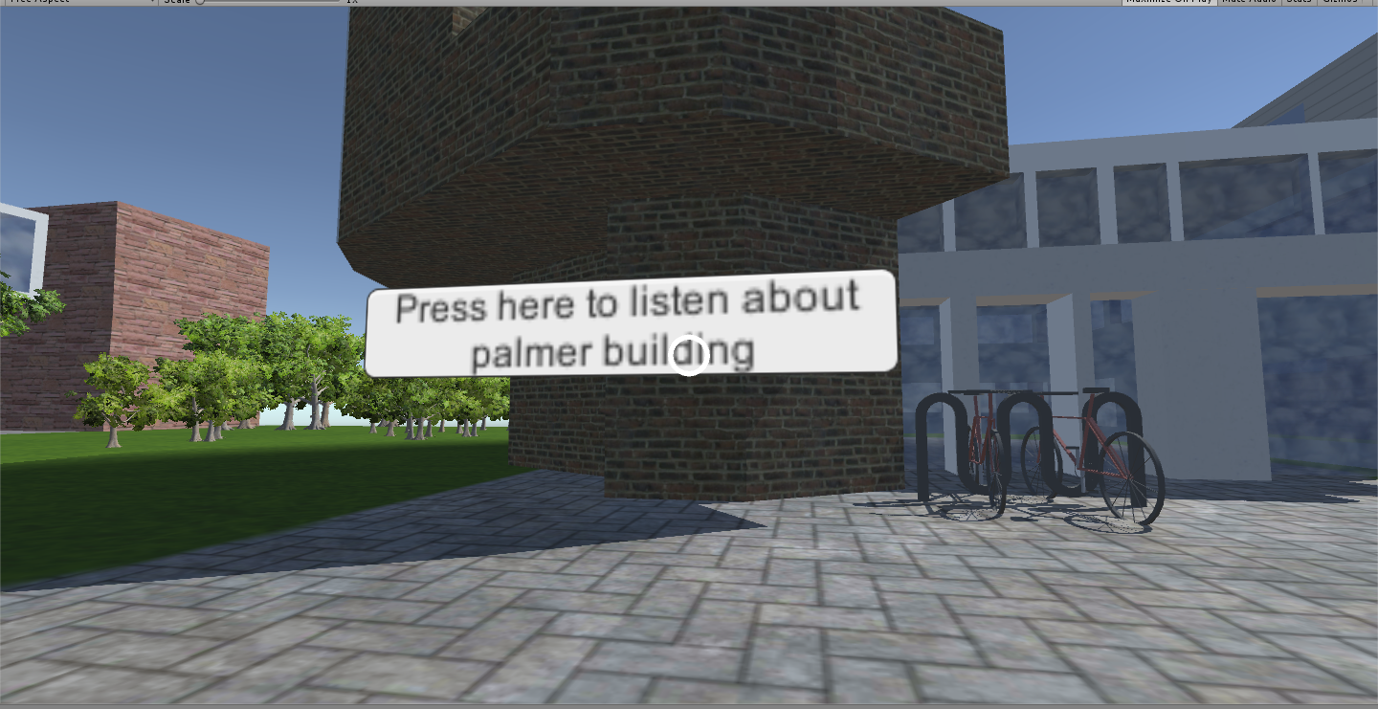

Figure 6 A example of having a button to press inside the virtual campus world, the circle will change shape indicating to the user that they can interact with the button

### 6.2 – Camera Control Scheme

For the camera control scheme, it is linked to the virtual headset. This was done thanks to the help of the Google VR SDK, with the prefabs that they have already provided. The way the camera controls work inside the virtual campus app is that the controls are linked to the main person’s head who is wearing the headset, so for example if the person wishes to look to their left, they must physical move their head in real life to the left to move the camera around. This control scheme works for all 360 directions, meaning the user isn’t limited to looking at left and right. The user can tilt their head if they wish to tilt the camera for any reason as well.

### 6.3 – Movement

To move the character, a teleport movement scheme was used, as mentioned before in the literature review and solution proposal. The way the teleport system works is that the user looks at a direction they wish to move in and they hold a button down which a circle indicator will appear, showing the area that they will teleport to. Once the user has let go of the button they will be instantly teleported to the area that the circle indicator was shown. The user can do this as many times as they want with no delay between each teleport.

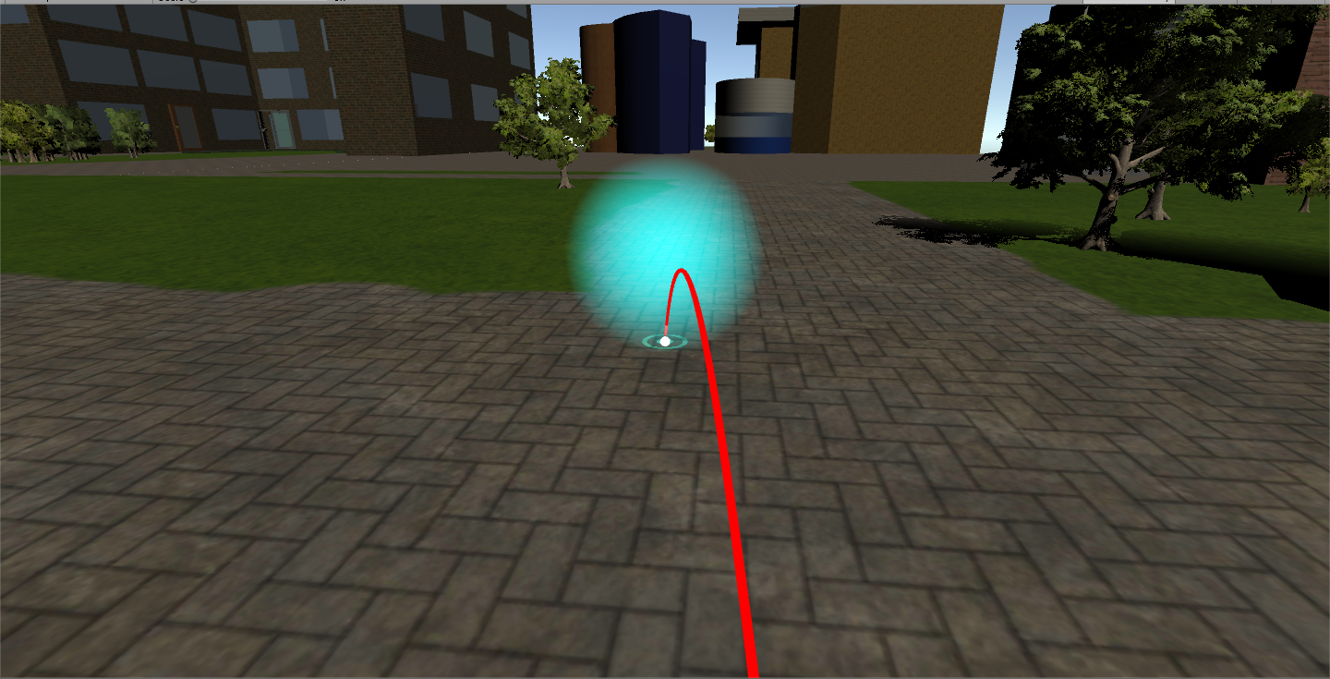

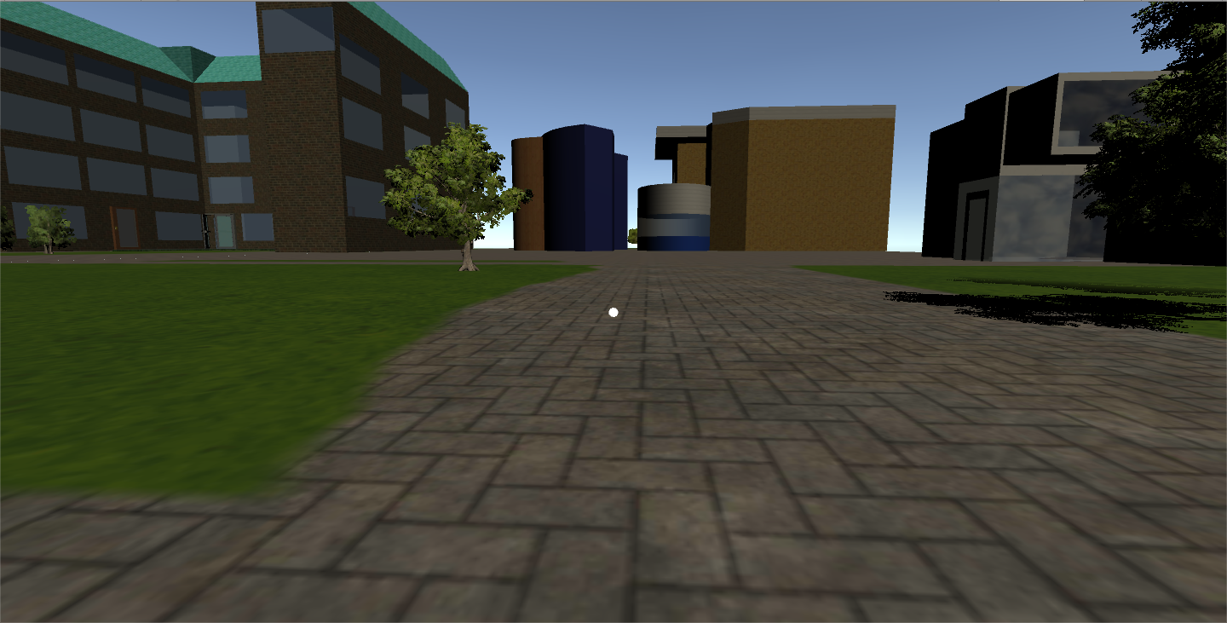

Figure 7 A screenshot showing the teleporter feature in action, as shown above the first screenshot shows the user selecting a location by holding the button down. Which makes the indicator appear, once the user has selected their location they are instantly teleported to the location that the circle indicator was. Which is shown in the second screenshot.

# 7. – Implementation

For the implementation section, this part is about the discussion of how each part of the virtual campus was implemented and designed into the main app of the virtual campus.

## 7.1 – Campus Ground design

For the campus grounds for the users to walk around in. I have created the campus grounds using the terrain tools that was made in Unity. To do this, I created a new terrain using the create tool and I edited the size of the terrain to 1500 and 1500. To save on lighting rendering time and making unity render lighting for one large terrain surface (A problem that I ran in mentioned in my logbook where, the terrain Timothy provided to me was too large and it took forever to render the lighting). The campus was split into several smaller square spaces, each square was given a name where the buildings were going to be placed. This help later when placing the buildings in each area, I based the design of the WhiteKnights campus grounds from using Google Maps.

To texture the Terrains of the campus grounds, I used the terrain texture tool. The first texture was setting the base texture (which was grass as campus is primarily a grassy area) then afterwards to add the pavement textures, I’ve added another texture from an asset and painted on top of the grass texture to make the pavements for the campus grounds. To paint the textures of the pavements, I based the locations of the pavements using Google Map Data.

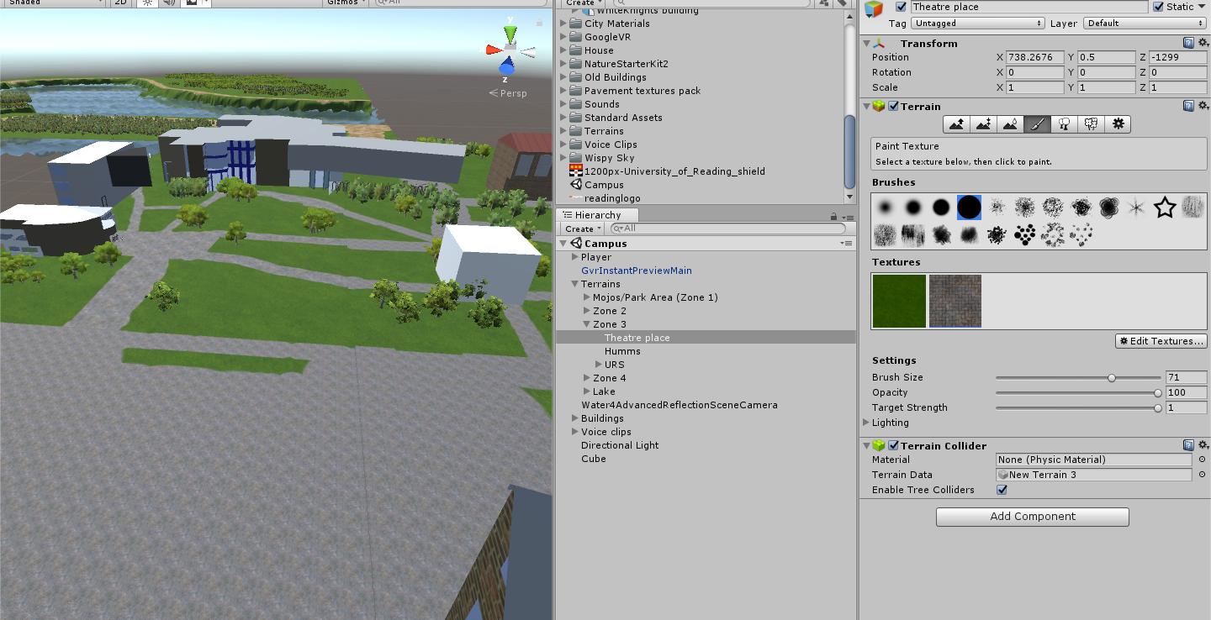

Figure 8 Screenshot of using the texture tool in unity

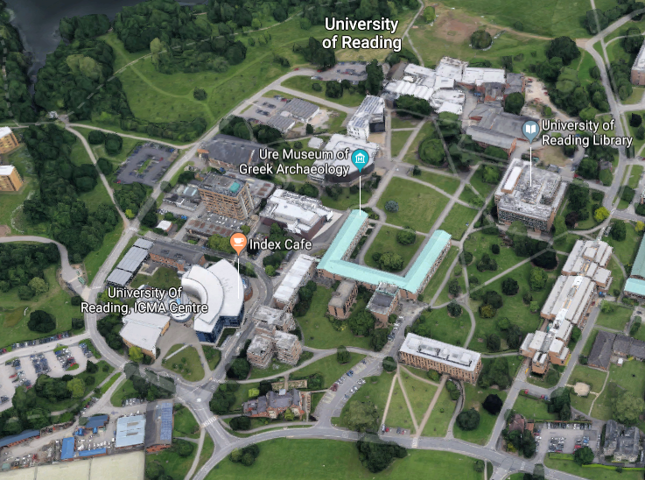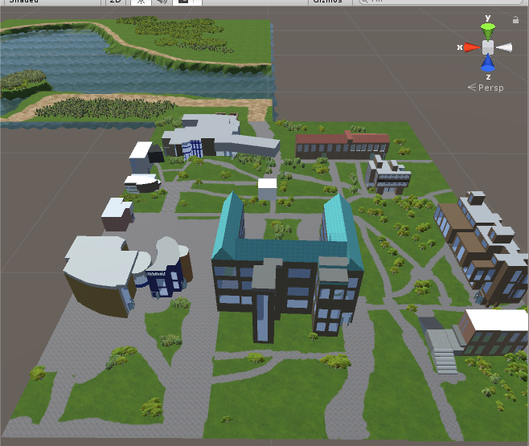

Figure 9 Using Google maps to design the overall layout of the pavement locations and where the position the buildings, it’s not an accurate 100% true to scale though, as I believe it would take ages to move from one location to another.

After that was done, I designed the lake by basing it on Google Maps, to add the water effect shown in the screenshot. To add the water inside the lake, I made the terrain setting lower and use the terrain terraform tool to lower parts of the terrain to make the lake base, afterwards I added the water through Unity’s assets and resize of the water pool to add water into the lake.

I also added trees and bushes to the campus grounds by using the inbuilt tree tools that Unity supplies. Like the painting the texture tools, the tree tool uses a paintbrush tool to generate trees on the campus ground. I placed the trees and bushes based on Google Maps and photos I took on campus.

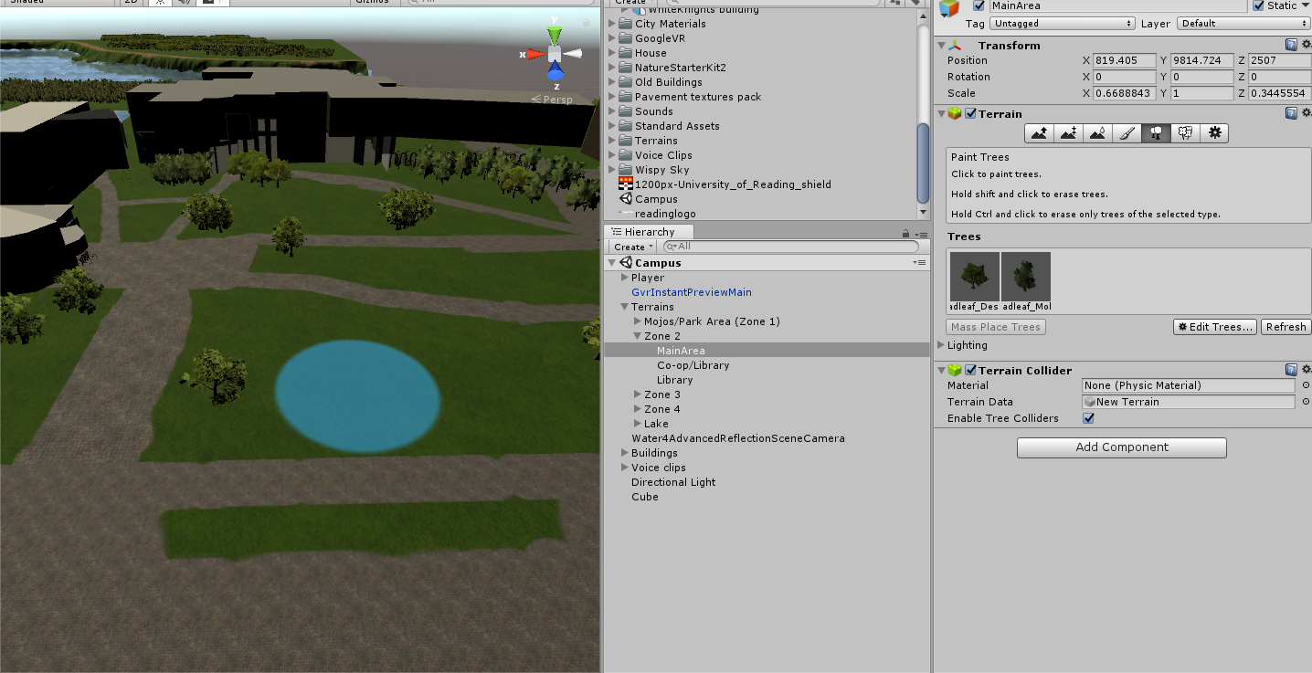

Figure 10 Using the tree tool to paint trees onto campus in unity

## 7.2 – Building design

To design the buildings featured inside the virtual campus, I went around WhiteKnights Campus and took several photos of the campus and its buildings (The link of the photos of the buildings can be found here:

<https://drive.google.com/open?id=1eXYKl3vXmljyhCB6fUtWI806828mBcG4>).

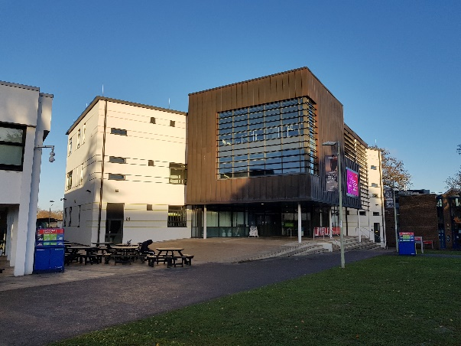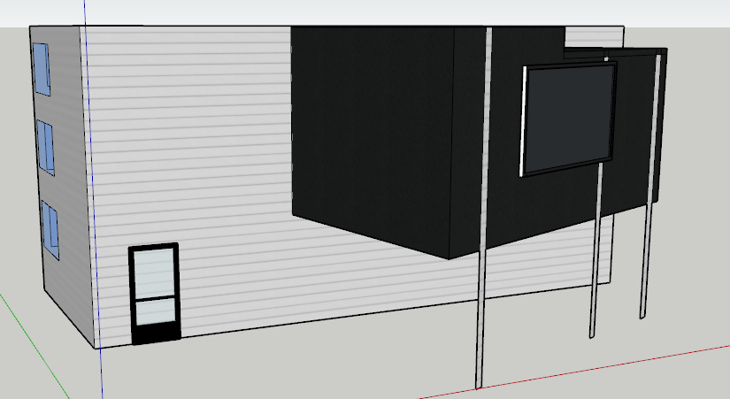

Figure 11 On the left side there is a picture of Carrington building on the right side there 3D model version of Carrington building made using SketchUp

After taking photos of the buildings, I used SketchUp to design and model the buildings. First to design the buildings I drew a flat 2D overview of the building (The 2D top down view of the building was done by using the map view of Google Maps), afterwards I used the pull tool to make a 3D version of the 2D drawing. Afterwards, to add detail to the models, I used the photos for reference of what the buildings should look like. Sadly, I couldn’t detail the building to accurate representation due to the limited texture that SketchUp has. To add details and features to the buildings (Such as the windows and doors), I used the rectangle tool to draw onto the sides of the building afterwards I used the Glass Texture that SketchUp provides to add the windows to the buildings. Too add the doors, I used the 3D warehouse tool that SketchUp provided and downloaded a Glass door model and added it to the sides of the building where the doors are normally placed.

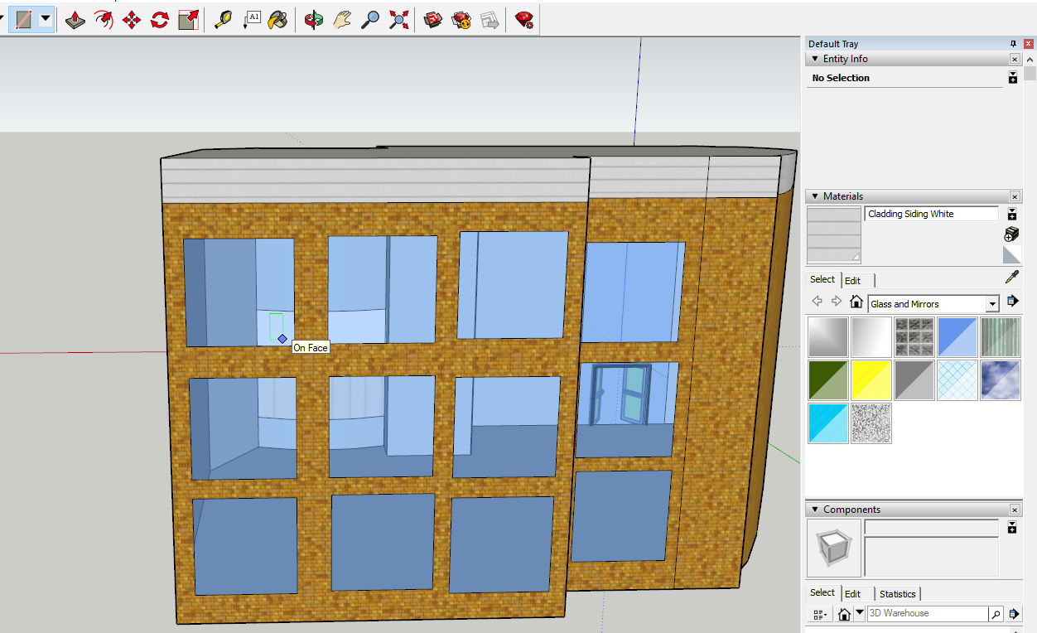

Figure 12 Creating windows on buildings using the rectangle and glass texturing tool in SketchUp

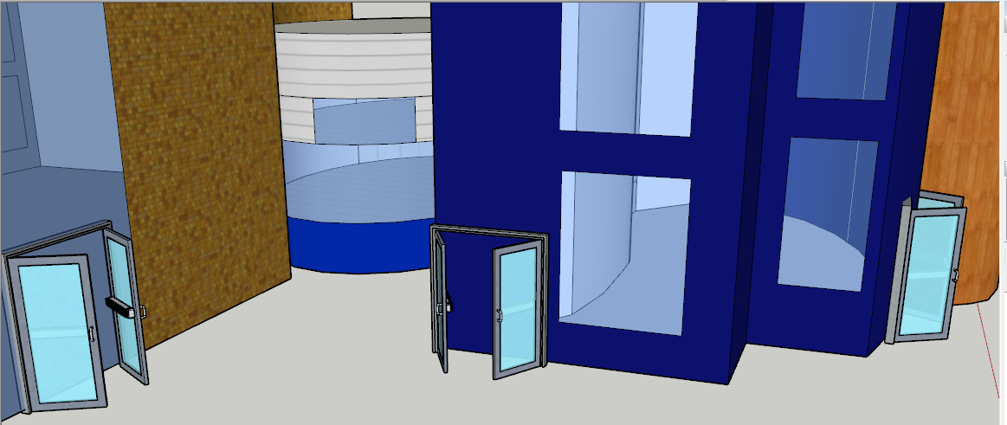

Figure 13 Adding glass doors to buildings using the 3D warehouse tool in SketchUp

## 7.3 – Adding buttons to the buildings for narration

For users to listen to narration for each building, buttons were added into virtual campus (By making it render into the world space rather than on the user’s screen) so users can choose which building they want to hear the backstory/history to. To do this, I recorded audio for each building using audacity and saved it as a Wav file and then imported the sound clips into the Unity Project (The script for each building can be seen at the appendix at the bottom of the document). To assign audio clips to each building, I have created a button for each building and for each button I coded the button to play the selected audio clip when the user presses the button, to do this I made each audio source not to “play on awake” and only to play the audio source when the button was pressed.

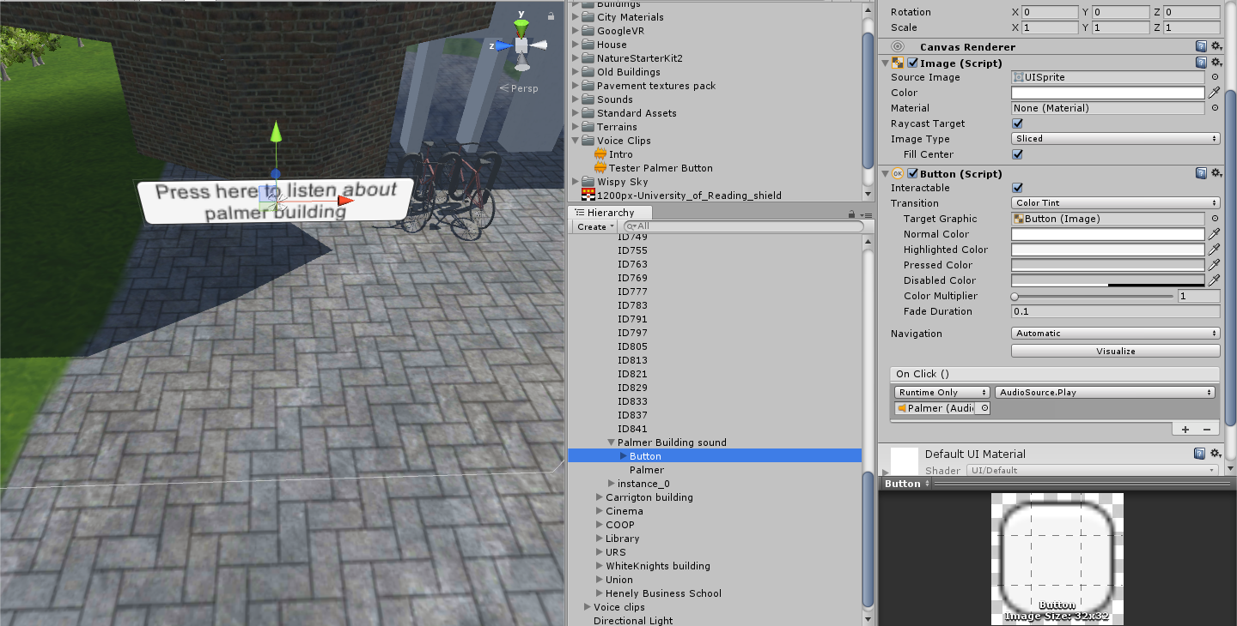

Figure 14 Adding buttons into the virtual campus

So, when it’s rendering inside the world users can interact with the button and listen to the narration of the building by walking up to it and pressing the button.

## 7.4 – Movement

To implement movement into virtual campus, the script was made from following a YouTube tutorial [12] [13]. The code was added into the project shown below:



Figure 15 Code used for the teleportation movement from the YouTube tutorial [13]

The code provided renders a red line and a circle when the user presses a button and once the user let goes of the button the user is instantly teleported there. The code also allows for the teleport script to be usable in the play tool (Or run tool) by using a mouse, this allows to save time as unity doesn’t need to be constantly build APKs to test out and debug features inside the app.



Figure 16 The teleport code in action, running on the android device.

To enable the script, I added the script inside the player tag. In unity, code can work depending on where the script is placed in the project hierarchy. Since the code can only work if it is put inside the “Player” tag.

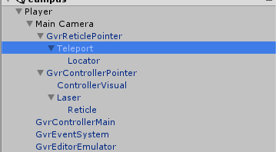

Figure 17 Adding the teleport inside the project hierarchy, it is added to the main camera because it enables the user to see the world, since it is virtual reality, the main camera will be linked to the player character since it will be in first person. The teleport script will be added to the “GvrReticlePointer” since that script will be used for the user to point and interact with the virtual campus.

## 7.5 – Camera control

To allow the user to move the camera around. Like the teleport script, the “*GvrControllerMain*” prefab from Google Cardboard’s SDK [6]. To implement it, this script was added to the Player tag in the project hierarchy. As this tag determines all the controls for the player control and vision. *GvrControllerMain* identical to the Teleport script allows for mouse input in the run mode. Increasing the efficiency of the production of this application as unity doesn’t need to be constantly build APKs to test out and debug features inside the app.

## 7.6 – Optimisation

For optimisation of the application, to prevent the smartphone suffering from performance issues, the app is designed not to render all the campus at once, only a limited part of the campus is rendered. This is done so it won’t put strain onto the phone by forcing it to render a lot of 3d models as well as needing to render the lake when the user is not even near it. To achieve this, the settings in the main camera was changed. The field of view was set to 60 by default as 60 FOV (Field of View) is fine enough for mobile devices since the screen is small compared to a computer monitor, for the clipping planes which determines how far the screen should render the campus, this was set to 1000 as it shown enough campus to avoid the user getting lost and confused if the max distance was set to low, but it’s not high enough to prevent the phone from slowing down by forcing it to rendering everything at once.

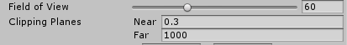

Figure 18 The settings to show how far the campus can be rendered

## 7.7 – Summary

To summarise the implementation section, the campus grounds in virtual campus was built using the terrain tools from Unity. The texturing was done by adding a base texture to the terrain and then painting over some of the terrain by using the paint brush tool. The trees were generated the same way as well since unity offers a paint brush tool to “paint” the trees into the environment. The placement of the trees and the texturization of the campus grounds was based from using Google Maps Satellite pictures. The water in WhiteKnights Lake was made by using Unity’s standard assets. To model the buildings inside the virtual campus, photos was taken of most buildings on WhiteKnights Campus and SketchUp was used to model and texturized the buildings.

For the control scheme, the user will control the application by using their heads in real life (through the virtual reality headset, using the phone’s gyroscope) to move the camera which is handle by the *GvrControllerMain* function. For teleportation the user will point at a direction and press a button which will activate the *laser* and *reticle* function which will be used to generate the circle indicator that will show where the user will teleport to. Afterwards once the user has chosen the location they wish to teleport to, then the *teleport* function will be used instantly teleporting to the location which is defined by the user.

To allow users to listen to narration in the virtual campus, buttons were rendered inside the world by using Unity’s button tool, the buttons were modified to play an audio clip when the user presses a button instead of instantly playing when the app is launched. When the user walks up to a button, the *GvrReticlePointer* function is used as the circle will change shaped to indicated to the user that the object that they are looking at can be interacted with.

Finally, for optimisation the FOV was set to 60 as the user doesn’t need to see the campus wide enough to avoid getting “fish eyes” lenses. The clipping plane far size was set to 1000 as it is a suitable distance for the user to see where they are currently going and not to high enough to avoid putting strain on the phone by making it render everything at once.

# 8. – Testing

# 9. – Discussion

# 10. – Social, Legal, Health & Safety & Ethical Issues

# 11. – Conclusion/Reflection and Future Improvements

# 13. – Appendices

## 13.1 – Project Initiation Document

**Individual Project (CS3IP16)**

**Department of Computer Science**

**University of Reading**

**Project Initiation Document**

**PID Sign-Off**

|  |  |
| --- | --- |
| **Student No.** | **24015209** |
| **Student Name** | **James Tang** |
| **Email** | [**Xr015209@reading.ac.uk**](mailto:Xr015209@reading.ac.uk) |
| **Degree programme** (BSc CS/BSc IT) | **BSc CS** |
|  |  |
| **Supervisor Name** | **Timothy Threadgold** |
| **Supervisor Signature** |  |
| **Date** |  |

SECTION 1 – General Information

**Project Identification**

|  |  |
| --- | --- |
| **1.1** | **Project ID**  (as in handbook) |
|  | 150 |
| **1.2** | **Project Title** |
|  | Virtual Campus |
| **1.3** | **Briefly describe the main purpose of the project in no more than 25 words** |
|  | Create models of parts of the campus using SketchUp or blender which can be explored using a robot and explored in unity |

**Student Identification**

|  |  |
| --- | --- |
| **1.4** | **Student Name(s), Course, Email address(s)**  e.g. Anne Other, BSc CS, a.other@student.reading.ac.uk |
|  | James Tang, BSc CS, xr015209@live.reading.ac.uk |

**Supervisor Identification**

|  |  |
| --- | --- |
| **1.5** | **Primary Supervisor Name, Email address**  e.g. Prof Anne Other, a.other@reading.ac.uk |
|  | Timothy Threadgold, timothy.threadgold@reading.ac.uk |
| **1.6** | **Secondary Supervisor Name, Email address**  Only fill in this section if a secondary supervisor has been assigned to your project |
|  |  |

**Company Partner (only complete if there is a company involved)**

|  |  |
| --- | --- |
| **1.7** | **Company Name** |
|  |  |
| **1.8** | **Company Address** |
|  |  |
| **1.9** | **Name, email and phone number of Company Supervisor or Primary Contact** |
|  |  |

SECTION 2 – Project Description

|  |  |
| --- | --- |
| **2.1** | **Summarise the background research for the project in about 400 words. You must include references in this section but don’t count them in the word count.** |
|  | The background research I have done for this, I have researched various ways to control how the user would move and view around a virtual space, I primarily used Google Maps Street view, Google Cardboard and Google Earth VR as my background research.  I used Google Cardboard’s Tour guide feature, which my primarily inspiration for voiced guide tours, Google Maps Street views which allows you to explore inside of some buildings on the map gave me inspiration for moving around inside buildings to view what the inside of a building looks like.  Inspiration I got for moving around the map was primarily from watching footage of VR games, where the user just points to a location and teleports to it. |
| **2.2** | **Summarise the project objectives and outputs in about 400 words.** These objectives and outputs should appear as tasks, milestones and deliverables in your project plan. In general, an objective is something you can do and an output is something you produce – one leads to the other. |
|  | The objectives and outputs are:   * Get photos of the campus buildings such as: structures of the building, inside of the building including most of its rooms. This allows for modelling the outside of the building and inside the buildings as well. * Get photos and map of the campus grounds (Half of Whiteknights campus including the lake) to model the outside parts of campus. Once this is done, then the buildings can be successfully placed on the outside areas (Once they are modelled). * Model the buildings using SketchUp, once the buildings have been modelled then use SketchUp again to model the outside areas. * Once both have been completed, use unity to place the buildings and outside map areas together to form the basis of the virtual campus. * Add in voice lines, which reads out loud to the user about information about the current area they are in. * Use unity to code the virtual reality part where users can move around and interact with the environment (such as guided tours, or information about the buildings/area). * Once all is completed, test the virtual reality out and test for bugs/potential problems users may run into. |
| **2.3** | **Initial project specification - list key features and functions of your finished project.** Remember that a specification should not usually propose the solution. For example, your project may require open source datasets so add that to the specification but don’t state how that data-link will be achieved – that comes later. |
|  | * Fully explorable central white knight’s campus, from Chancellor buildings to Halls to the lake. * Users can explore inside of most of the buildings, there is some interactive elements (Mostly buttons users can press which gives out information about the current building that they are in). * Some parts of the buildings can be interacted with. * Guided tours of the campus, users can select one of three tours (May be more in the future) which gives them a personal tour of each part of the campus, with a pre-recorded guide tour.     *Figure 19 Purposed plan of explorable area which the virtual campus tour would be like* |
| **2.4** | **Describe the social, legal and ethical issues that apply to your project. Does your project require ethical approval?** |
|  | None of that I know of, possible legal issues are required permissions to take pictures of campus and permissions to use information about the campus. |
| **2.5** | **Identify and lists the items you expect to need to purchase for your project. Specify the cost (include VAT and shipping if known) of each item as well as the supplier.** e.g. item 1 name, supplier, cost |
|  | * Vive set, Vive, £599 or Oculus Rift + Touch, Oculus, £499   + Used for Virtual reality testing * Google SketchUp, Google, Free (But may possibly need the pro version, $695) or Blender   + Used to create models of the campus * Unity, Unity, Free (May need to purchase the pro features to access the virtual reality features, in this case it is $125 per a month)   + Used to code in the virtual reality parts |
| **2.6** | **State whether you need access to specific resources within the department or the University e.g. special devices and workshop** |
|  | Need access to virtual reality tools (such as oculus rift or Vive) and a room to test out the virtual reality parts. |

SECTION 3 – Project Plan

|  |  |  |  |
| --- | --- | --- | --- |
| **3.1** | **Project Plan**  Split your project work into sections/categories/phases and add tasks for each of these sections. It is likely that the high-level objectives you identified in section 2.2 become sections here. The outputs from section 2.2 should appear in the Outputs column here. Remember to include tasks for your project presentation, project demos, producing your poster, and writing up your report. | | |
|  | | | |
| **Task No.** | **Task description** | **Effort**  **(weeks)** | **Outputs** |
| **1** |  |  |  |
| 1.1 | **Background Research** | 3 | … |
| 1.2 | Get pictures of buildings | 1 | Models for of buildings |
| 1.3 | Get pictures of campus | 1 | Models of campus |
| 1.4 | Get information about WhiteKnights campus | 1 | Voice lines of guided tours |
| **2** | **Analysis and design** |  |  |
| 2.1 | Design Buildings (insides as well) | 12 | Building models |
| 2.2 | Design outside parts of campus | 3 | Outside models |
| 2.3 | Get voice recordings | 1 | Used for guided tours part |
| **3** | **Develop prototype** |  |  |
| 3.1 | Combine both buildings and campus into one | 3 | Campus set for virtual reality |
| 3.2 | Make the virtual reality part controllable | 6 | Controllable virtual campus |
|  |  |  |  |
| **4** | **Testing, evaluation/validation** | 3 |  |
| 4.1 | Test virtual reality (self) | 1 | Bug fix report |
| 4.2 | Have a group test of the virtual reality | 1 | Bug fix report and feedback |
| 4.3 | Change parts of the virtual reality based on possible feedback | 1 | Hopefully a better version of the prototype |
| **5** | **Assessments** |  |  |
| 5.1 | write-up project report | 2 | Project Report |
| 5.2 | produce poster | 0.5 | Poster |
|  | … |  |  |
|  |  |  |  |
|  |  |  |  |
|  |  |  |  |
|  |  |  |  |
|  |  |  |  |
| **TOTAL** | **Sum of total effort in weeks** | **39.5** |  |

|  |  |  |  |  |  |  |  |  |  |  |  |  |  |
| --- | --- | --- | --- | --- | --- | --- | --- | --- | --- | --- | --- | --- | --- |
| **SECTION 4 - Time Plan for the proposed Project work** | | | | | | | | | | | | | |
| For each task identified in 3.1, please *shade* the weeks when you’ll be working on that task. You should also mark target milestones, outputs and key decision points. To shade a cell in MS Word, move the mouse to the top left of cell until the curser becomes an arrow pointing up, left click to select the cell and then right click and select ‘borders and shading’. Under the shading tab pick an appropriate grey colour and click ok. | | | | | | | | | | | | | |
| **Project stage** | **START DATE: 06/10/17 <enter the project start date here>**  **Project Weeks** | | | | | | | | | | | | |
| 0-3 | 3-6 | 6-9 | 9-12 | 12-15 | 15-18 | 18-21 | 21-24 | 24-27 | 27-30 | 30-33 | 33-36 | 36-39 |
| **1 Background Research** |  |  |  |  |  |  |  |  |  |  |  |  |  |
| Get pictures of buildings |  |  |  |  |  |  |  |  |  |  |  |  |  |
| Get information about WhiteKnights campus |  |  |  |  |  |  |  |  |  |  |  |  |  |
| **2 Analysis/Design** |  |  |  |  |  |  |  |  |  |  |  |  |  |
| Design Buildings (insides as well) |  |  |  |  |  |  |  |  |  |  |  |  |  |
| Design outside parts of campus |  |  |  |  |  |  |  |  |  |  |  |  |  |
| Get voice recordings |  |  |  |  |  |  |  |  |  |  |  |  |  |
| **3 Develop prototype.** |  |  |  |  |  |  |  |  |  |  |  |  |  |
| Combine both buildings and campus into one |  |  |  |  |  |  |  |  |  |  |  |  |  |
| Make the virtual reality part controllable |  |  |  |  |  |  |  |  |  |  |  |  |  |
| **4 Testing, evaluation/validation** |  |  |  |  |  |  |  |  |  |  |  |  |  |
| Test virtual reality (self) |  |  |  |  |  |  |  |  |  |  |  |  |  |
| Have a group test of the virtual reality |  |  |  |  |  |  |  |  |  |  |  |  |  |
| Change parts of the virtual reality based on possible feedback |  |  |  |  |  |  |  |  |  |  |  |  |  |
| **5 Assessments** |  |  |  |  |  |  |  |  |  |  |  |  |  |
| **write-up project report** |  |  |  |  |  |  |  |  |  |  |  |  |  |
| **produce poster** |  |  |  |  |  |  |  |  |  |  |  |  |  |
|  |  |  |  |  |  |  |  |  |  |  |  |  |  |

**Risk Assessment Form**

|  |  |  |  |
| --- | --- | --- | --- |
| **Assessment Reference No.** |  | **Area or activity assessed:** | **The room where the VR headset is currently set in** |
| **Assessment date** |  |
| **Persons who may be affected by the activity (i.e. are at risk)** | **Person is currently using the VR headset** |

**SECTION 1: Identify Hazards -** *Consider the activity or work area and identify if any of the hazards listed below are significant (tick the boxes that apply).*

|  |  |  |  |  |  |  |  |  |  |  |  |  |  |  |  |  |  |
| --- | --- | --- | --- | --- | --- | --- | --- | --- | --- | --- | --- | --- | --- | --- | --- | --- | --- |
|  | Fall of person (from work at height) | ✓ |  | Lighting levels | ✓ |  | Use of portable tools / equipment | ✓ |  | Vehicles / driving at work |  |  | Hazardous fumes,  chemicals, dust |  |  | Occupational stress |  |
|  | Fall of objects | ✓ |  | Heating & ventilation |  |  | Fixed machinery or lifting equipment |  |  | Outdoor work / extreme weather |  |  | Hazardous biological agent |  |  | Violence to staff / verbal assault |  |
|  | Slips, Trips & Housekeeping | ✓ |  | Layout, storage, space, obstructions | ✓ |  | Pressure vessels |  |  | Fieldtrips / field work |  |  | Confined space / asphyxiation risk |  |  | Work with animals |  |
|  | Manual handling operations |  |  | Welfare facilities |  |  | Noise or Vibration |  |  | Radiation sources |  |  | Condition of Buildings & glazing |  |  | Lone working / work out of hours | ✓ |
| 1. **55** | Display screen equipment | ✓ |  | Electrical Equipment | ✓ |  | Fire hazards & flammable material |  |  | Work with lasers |  |  | Food preparation |  |  | Other(s) - specify |  |

**SECTION 2: Risk Controls** *- For each hazard identified in Section 1, complete Section 2.*

|  |  |  |  |  |  |  |
| --- | --- | --- | --- | --- | --- | --- |
| **Hazard No**. | Hazard Description | Existing controls to reduce risk | **Risk Level** (tick one) | | | Further action needed to reduce risks |
|  | High | Med | Low | *(provide timescales and initials of person responsible)* |
| 1 | User using the VR headset may not be aware of it’s current (in real life) surrounding and thus may trip/fall/bump into an object | Make the room empty and spacious |  | ✓ |  | Have a person supervise the current user using the VR set and support them should they fall. |
| 2 | Prolong use of the VR headset may cause eye strain/damage |  | ✓ |  |  | Have a person supervise the current user using the VR set the amount of time they have been on and warn them to get off once they reach a certain limit (15 minutes for example) |
| 3 | User may get nauseous when using VR (In general or for the first time) |  |  | ✓ |  | Have a person supervise the current user using the VR set and teach them how to use VR for the first time. |
| **Name of Assessor(s)** | |  | **SIGNED** | | | |
| **Review date** | |  |

|  |  |  |
| --- | --- | --- |
| **Health and Safety Risk Assessments** – continuation sheet | **Assessment Reference No** |  |
|  | **Continuation sheet number:** |  |

**SECTION 2 continued: Risk Controls**

|  |  |  |  |  |  |  |  |  |
| --- | --- | --- | --- | --- | --- | --- | --- | --- |
| **Hazard No**. | Hazard Description | | Existing controls to reduce risk | **Risk Level** (tick one) | | | | Further action needed to reduce risks |
|  | High | | Med | Low | *(provide timescales and initials of person responsible for action)* |
| 4 | User may accidentally throw the VR Remotes at someone or something, potentially damaging them | | There are straps on the VR remote | ✓ | |  |  | Make sure the person supervising them enforces the users to put the strap on |
| 5 | Liquids poses a great risk to the VR set & computer running it since it is electrical | | No Liquids allowed signs in the room | ✓ | |  |  | Make sure the person supervising them prevent the user from consuming/bringing liquids. If the user needs to consume liquids, tell them to consume it outside of the room. |
|  |  | |  |  | |  |  |  |
| **Name of Assessor(s)** | |  | | | **SIGNED** | | | |
| **Review date** | |  | | |

## 13.2 – Project Log Book

Individual Project Report – Virtual Campus

UNIVERSITY of reading | jAMES TANG | 24015209

Signoff table and summary

|  |  |  |
| --- | --- | --- |
| Date | Summary of date/week | Signature |
| 18.09.17 | Choosing project theme |  |
| 10.10.17 | Research on project |  |
| 13.10.17 | Choosing and testing programs |  |
| 16.10.17 | Testing out Unity |  |
| 18.10.17 | Testing out SketchUp |  |
| 20.10.17 | Choosing movement type |  |
| 6.11.17 | First initial prototype |  |
| 17.11.17 | Importing terrain |  |
| 20.11.17 | Restarting again |  |
| 21.11.17 | Adding terrain |  |
| 30.11.17 | Photoshoot of buildings |  |
| 4.12.17 | Texturing of the ground |  |
| 11.12.17 | Adding in movement |  |
| 8.1.18 | Adding in central buildings |  |
| 18.1.18 | Creating Lake |  |
| 25.1.18 | Adding in voices |  |
| 26.2.18 | Implementation of adding voices |  |
| 8.2.18 | First build of the project |  |
| 15.2.18 | First demo of the project |  |
| 19.2.18 | Importing to GitHub |  |
| 26.2.18 | Adding trees to campus |  |
| 17.4.18 | Texturizing of all the buildings |  |

1 – Choosing a project theme

For my Final Year Project, I must choose a project theme, so out of all the project choices I end up choosing, I chose Virtual Campus because it was the most interesting to me out of all the project theme choices and I have a keen interest in Virtual Reality. So, this was the perfect choice for me.

2 – Research on project

To do research on my project, I decided to research on multiple topics, such as how will the campus looks like in reality and how I will design the buildings, what programs I will use to achieve my goals, why am I creating this virtual campus and who is the target audience for. The next sections in this logbook will explain in detail about most of the goals.

For my target audience, I decided to base this on users who wanted to attend this university but however they are not able to attend the open days for a matter of factors (such as money issues, location/distance and/or bad timing). So, I decided to make this virtual campus for employees of university to bring the open day to them instead of them coming here. The application was originally going to be created for Windows but instead I switched to Android devices because most users today have virtual reality installed on their phones. Also, there is the possibility that their computers may not have the hardware to run virtual reality. So, I switched to android devices so users can install the application to their phones at any point even if they miss out the chance if test out the virtual reality campus on an open day.

3 – Choosing and testing programs

I had to choose and test programs to create the Virtual Campus, I decided to go with the recommend programs that the University provided me, which were Unity, SketchUp and Blender. The next two sections explain in detail about how the testing went. However, I didn’t use Blender because I found Blender to complex and difficult compared to using SketchUp to model buildings.

4 – Testing out Unity

I have tested out Unity, to see if it is suitable for helping me creating the main virtual reality program itself. I have never tried Unity before however it provides an easy to use tutorial and allows the user to understand the basics. Thanks to the tutorial provided and the easy to use interface of creating game, I will be using unity to create the Virtual Campus.



*Figure 20 Screenshot of unity*

5 – Testing out SketchUp

I have tested out SketchUp, to see if it is suitable for helping me create my models. I was familiar with SketchUp before, but I decided to test the program again, SketchUp Allows for easier building creation compared to blender, as it allows to create buildings via sculping where you draw an outline of the building and then you use the pull function to generate an 3D version of the outline of the building, I decided to use SketchUp for building generation as it allows for easy building creation and texturing.



*Figure 21 Screenshot of SketchUp*

6 – Choosing movement type

To choose the movement type of moving around the virtual campus, I had to research the possible types of movement in virtual reality. The three movement types that interested me were:

Teleport based movement

Free movement

Waypoint movement

Teleport based movements

Teleport based movements was the first movement that I researched after watching VR games that used this movement. Teleport based movement allows users to point at a location they wish to transport to via an indicator appearing. They press a button to instantly be teleported there, they can teleport to any place that they wanted granted they have permissions to do so.

Free movement

Free movement allows users to move in a direction that they want, without needing to pause. This allows for the most realistic movement of virtual reality however it causes the most motion sickness as their eyes believe that they are moving however their body in real life isn’t. So, in the end I won’t be using free movement as not many people have been exposed to Virtual Reality.

Waypoint movement

Waypoint movement allows users to choose a node or a point on the screen, that the programmer specified and the user can look at the node and then press a button to be teleported to that node. It allows the safest amount of moment for Virtual reality as compared to teleport based movement, users can potentially find errors and glitch by teleporting out of bounds by mistake, however it is the least restricted out of the three movement types are users are limited to moment by the nodes specified.

Conclusion

In conclusion, I chose teleport based movement because in the end, teleport based movement allows for the freest movement type of out of the three and it’s the movement type that will cause the least amount of motion sickness to the user and the user only moves when they want to move and it’s done via teleportation instead of free movement.

7 – First initial prototype

The first initial prototype of the first program was basically me trying to test out unity’s Virtual Reality features as well as exporting to android devices. The first scene allowed you to view a house, move your head around the environment however you weren’t allowed to move because it wasn’t implemented yet. It also had interactivity as you could press a button on the house which played an audio clip. Originally the virtual campus was going to be exported to Windows.

8 – Importing terrain

To import the terrain, Tim Threadgold helped me import the terrain by using a website [14], that allows you to create terrains from Google Maps by creating a heightmap for photoshop. Tim Threadgold helped me by sending me the files of the heightmap as I lacked Photoshop (As the website uses the photoshop scripts to create the terrain’s heights) to create the heightmap for the terrain.

Once the files have been imported into Unity, then I created a terrain and imported the heightmap into it, thus making the terrain of the campus. Despite how easy it sounded on paper and I was well ahead of finishing the Virtual Tour of campus, a problem occurred.

9 – Restarting again

Despite easily importing the terrain into the initial Whiteknights campus Terrain, there was a major problem with the initial terrain, the terrain was too big for the entire campus and there was a lot of issues rendering all the terrain and the shadows. It took too long to render not to mention if this is the issue of rendering every detail of the campus on my PC. Then chances are that my phone will not be able to render correctly when exported to android devices. So thus, the decision was made to restart the entire campus terrain from scratch and recreate it again.

10 – Adding terrain

Adding in terrain after restarting the entire campus again, was simpler and easier to render and build on my computer than the previous incarnation. To build the campus grounds again, I did a 3 by 3 square grid consisting of different terrains. So, it would be easier to paint pavements into the terrains. I based the terrain’s positions based on Google maps, facing east.

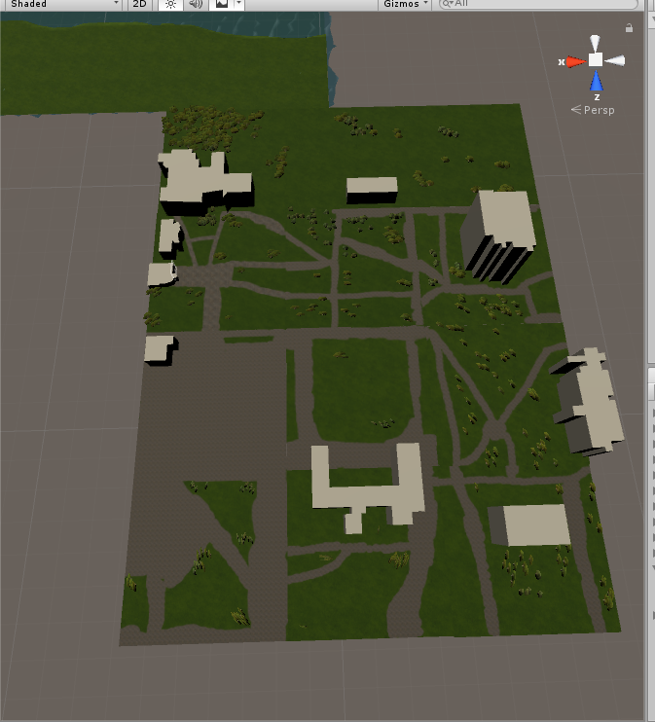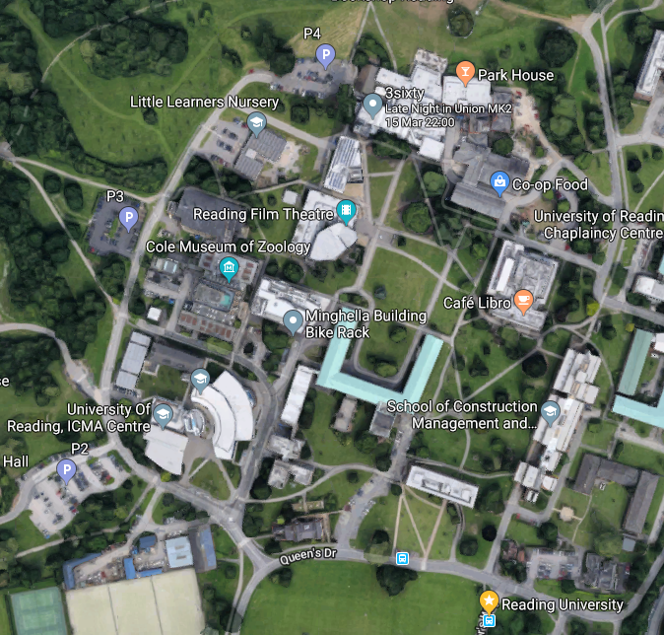

*Figure 22 Comparison of using terrain for unity and campus grounds*

11 – Photoshoot of buildings

To get referencing of what the buildings around Whiteknights campus and to somewhat accurately model the buildings. I decided to go to Whiteknights campus in real life and took photos of the various buildings that I intend to model inside the virtual campus. All the photos I took for referencing can be found here: <https://drive.google.com/drive/folders/1eXYKl3vXmljyhCB6fUtWI806828mBcG4?usp=sharing>.

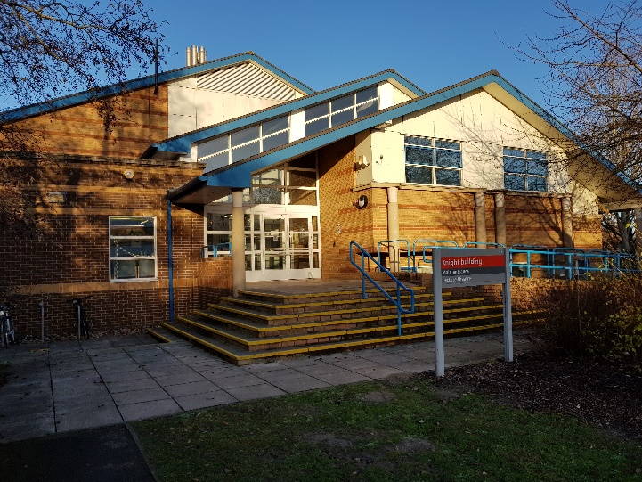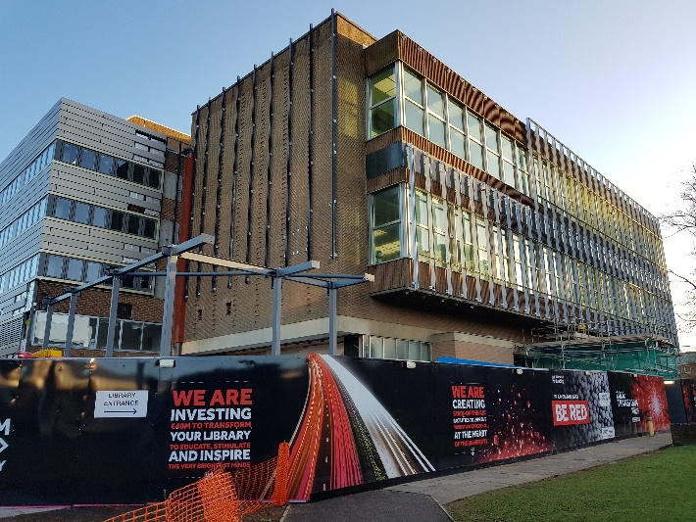

*Figure 23 Photos of buildings that I took, the photos are buildings of the Knights Building and Library*

12 – Texturing of the ground

To texture the grounds of the campus, I used the terrain painting tool in unity. First, I had to add in a base texture, which I used Unity’s standard assets for the grass texture which paints the entire terrain in grass, (as most of Whiteknights’ campus is grassy). To add pavements in campus, I used a paintbrush tool to paint directly onto the terrain. The texture used to make the pavement was from [15]. I painted the pavement based on google maps’ satellite view.

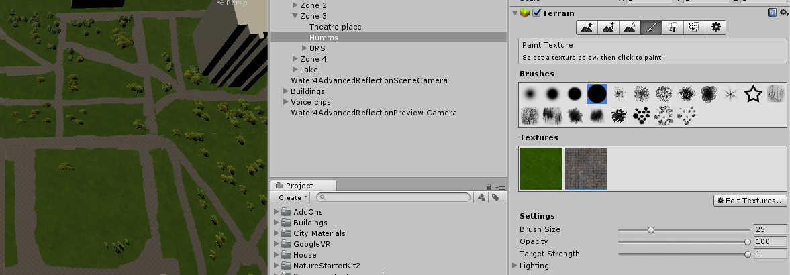

*Figure 24 Using the texture tool in unity*

13 – Adding in movement

To add in movement, I followed a YouTube tutorial [12] to add in teleport based movements, most of the code was already done by the tutorial and I used the prefab that he had provided already into the existing project. I have tweaked some of the code to make it easier for the user (Such as making the line bold).

14 – Adding in central buildings

To add in the central buildings, I have created and texturized every building using SketchUp. After each building was created, it was exported in a .skb file in order for it to be used in Unity. Afterwards the buildings are imported to unity and then placed inside the Virtual Campus, the buildings were placed in positions according to Google Maps.

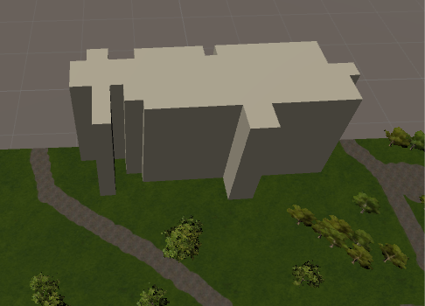

*Figure 25 Adding in a building to campus grounds (texture added later after this project logbook was made)*

15 – Creating Lake

To create the lake in the campus, a terrain was created first, to sculp the terrain, I had to change the terrain height (Terrain height is defaulted to 0, you can rise terrain however you cannot lower terrain which I wanted to do). Then sunk the terrain to make the lake, afterwards to add in the water, I imported the environment standard assets from unity and then I added a Water prefab into the lake, by placing it in the areas where the terrain has been lowered and thus creating the lake.

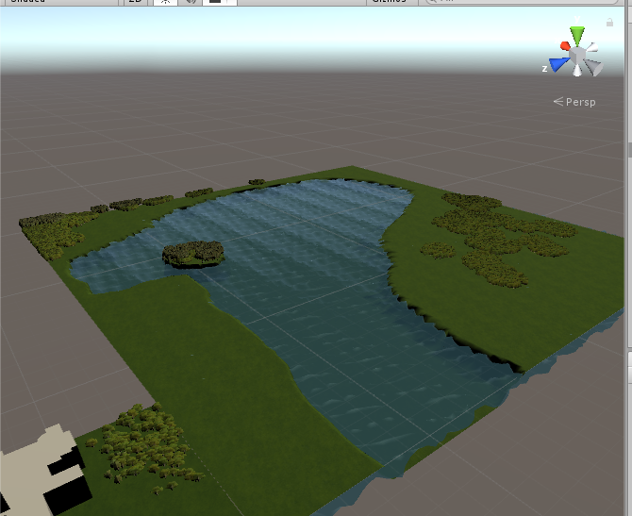

*Figure 26 What the lake looks like in unity*

16 – Adding in voices

I have added in voices, using a microphone and following a script that I have created. All audio was recorded using audacity.

17 – Implementation of adding voices

To successfully implement voices into the world for when the user wants to find out the history of the building. A button was created next to the buildings then when the user walks up to the button and presses it, then the sound clip will be activated playing the voice. To achieve this, the button was first created along with coding of what sound clip will be played when the button is pressed, afterwards the button is then added to world (It is usually defaulted to the User Interface) and then afterwards the button is placed next to the assigned building.

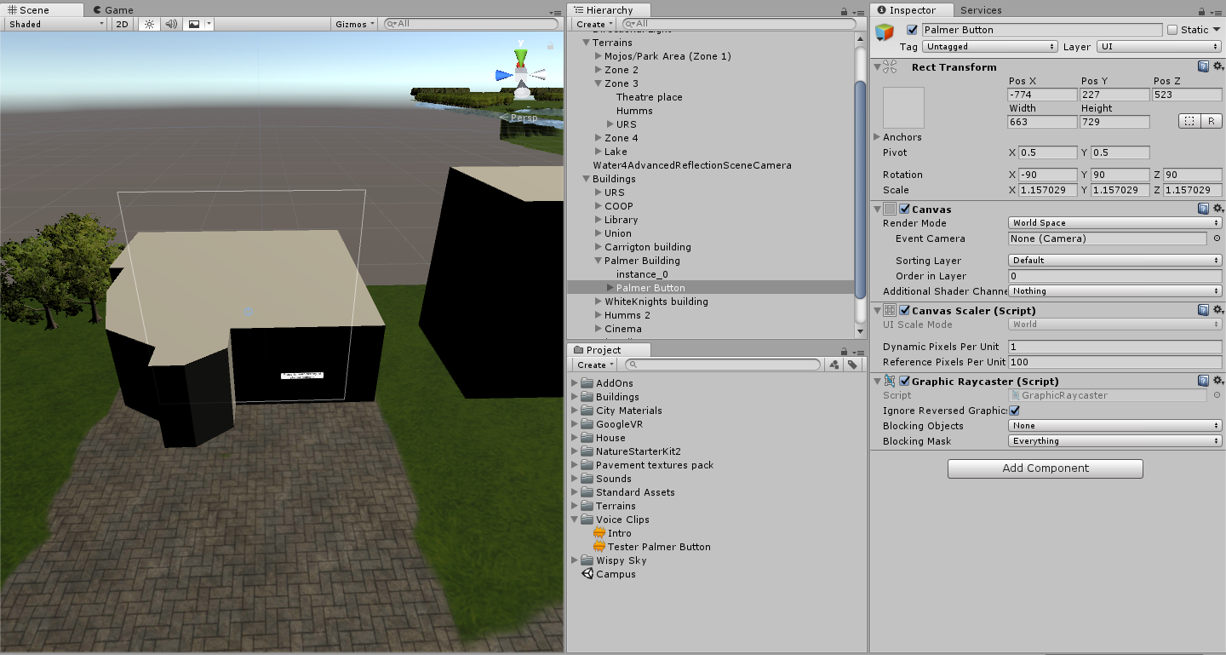

*Figure 27 Implementing the button into the world, so users can press a button a voice clip will play explaining the backstory of this building*

18 – First build of the project

The first build of the project was made using the Unity build settings. The settings exported was using Android, 32 bits and was built for nougat devices or higher (7.0 or higher). As older versions of android won’t be supported as they do not have daydream or cardboard installed (the service to run virtual reality on Android devices).

The first build was successful as it suffered no errors and bugs during launch and everything ran fine according to how it was built.

19 – First demo of the project

The first demo of the project was demoed on 15th February, I showed to my supervisor, Tim Threadgold on what I have done. The feedback was good, he has given me suggestions to improve my project which was to add a map feature, to add in a proper blink feature and to add a way to identifying the buildings.

20 – Importing to GitHub

I have imported the entire project into GitHub (In hindsight, this should have been done earlier however due to previously having a lack of knowledge and not feelings like I should use it, is the main reason why I didn’t use it until 19th February). The link can be found here: <https://github.com/JamesTang2905/Individual-Project-2017-18>

21 – Adding trees to campus

I have added trees from unity using the tree tool in the terrain settings. I have place trees based on the position of google maps.

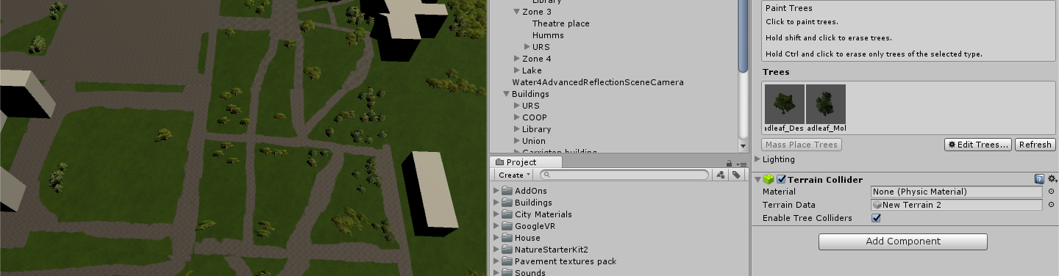

*Figure 28 Adding trees to the campus ground using the tree tools in unity.*

22 – Adding detail to the lake

I have added more detail to the lake, by adding pathways around the lake so the user won’t feel lost. I also have added more trees around the lake and Lake Ambience noises to add atmosphere around the lake and increase the realism.

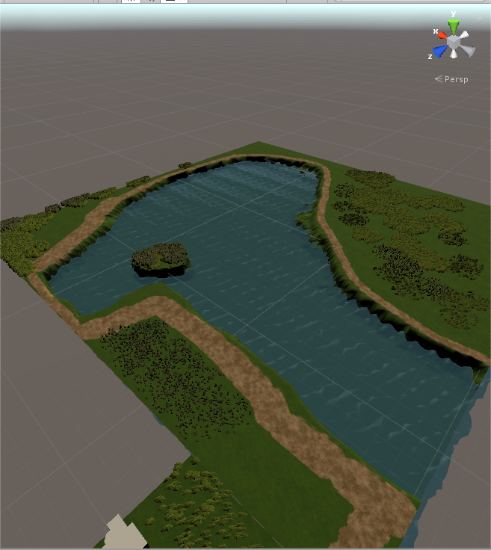

23 – Texturing buildings

I have texturized all the buildings featured in the campus, I done this by using SketchUp’s built-in texturing skills.

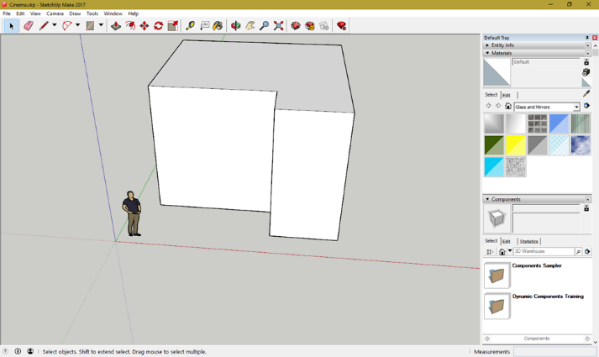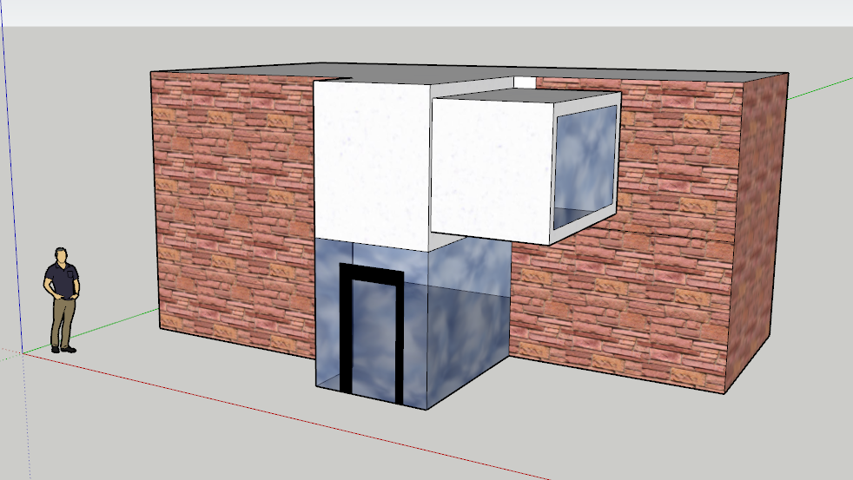

*Figure 29 Example of before and after of texturing the buildings, this is the cinema building shown in the screenshots before and after texturing and adding detail.*

## 13.4 – Script for buildings

## 13.5 – Map of WhiteKnights Campus

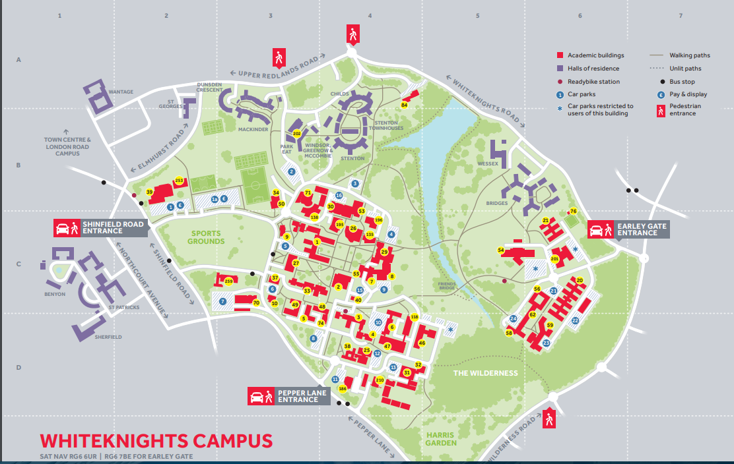

Figure 30 Map of WhiteKnights Campus - link: <https://www.reading.ac.uk/web/files/whiteknights-campus-map-and-keys-2016.pdf>

## 13.6 – GitHub Repository Link

<https://github.com/JamesTang2905/Individual-Project-2017-18> – This shows all the commits uploaded to GitHub, however it does not cover all the updates made before the 21st of February 2018 as this project wasn't uploaded to GitHub before then. Read the project logbook for a more detailed record.

# 14. – References

## Works Cited

|  |  |
| --- | --- |
| [1] | “Virtual reality,” 2017. [Online]. Available: https://en.wikipedia.org/wiki/Virtual_reality#2015%E2%80%93present. [Accessed 24 March 2018]. |
| [2] | Playstation, “Playstation VR,” Sony Interactive Entertainment, 13 October 2016. [Online]. Available: https://www.playstation.com/en-gb/explore/playstation-vr/. [Accessed 20 March 2018]. |
| [3] | J. Rogerson, “Mobile VR - What smartphones work with virtual reality?,” 3g, 6 September 2017. [Online]. Available: https://3g.co.uk/guides/what-smartphones-work-with-virtual-reality. [Accessed 20 March 2018]. |
| [4] | R. Waugh, “Which industries could benefit from virtual reality?,” The Telegraph, 17 August 2017. [Online]. Available: https://www.telegraph.co.uk/connect/small-business/tech/pc-world/benefits-of-virtual-reality/. [Accessed March 20 2018]. |
| [5] | Skills2Learn, “The Benefits of Virtual Reality and 3D Simulation,” 2015. [Online]. Available: http://www.skills2learn.com/virtual-reality-benefits.html. |
| [6] | R. Maxham, “Google VR SDK for Unity,” Google, 23 August 2017. [Online]. Available: https://github.com/googlevr/gvr-unity-sdk/releases. [Accessed 1 October 2017]. |
| [7] | A. Robertson, “The ultimate VR headset buyer’s guide,” The Verge, 2018. [Online]. Available: https://www.theverge.com/a/best-vr-headset-oculus-rift-samsung-gear-htc-vive-virtual-reality. [Accessed 20 March 2018]. |
| [8] | T. Moynihan, “Everything you need to know before buying a VR headset,” Wired, 3 March 2016. [Online]. Available: https://www.wired.com/2016/03/everything-need-know-buying-vr-headset/. [Accessed 1 April 2018]. |
| [9] | Nvidia, “System Requirements for VR,” 2017. [Online]. Available: https://www.geforce.co.uk/hardware/technology/vr/system-requirements. [Accessed 1 April 2018]. |
| [10] | F. Richter, “Which VR Headset Holds the Pole Position?,” Statista, 10 December 2015. [Online]. Available: https://www.statista.com/chart/4129/virtual-reality-consumer-awareness/. [Accessed 1 April 2018]. |
| [11] | Google, “Quickstart for Google VR SDK for Unity with Android,” Google, 2016. [Online]. Available: https://developers.google.com/vr/develop/unity/get-started-android. [Accessed 10 October 2017]. |
| [12] | BrainSock, “Revit to Unity : Adding Google VR & Teleport,” 25 November 2016. [Online]. Available: https://www.youtube.com/watch?v=JbkYLfdHwbg. [Accessed 5 February 2018]. |
| [13] | BrainSock, “Simple Google VR Teleporter,” 25 November 2016. [Online]. Available: https://bitbucket.org/cecetech/teleport/overview. [Accessed 5 February 2018]. |
| [14] | Darrenlloyd, “Heightmap creation from OS data. (UK Only),” 2013. [Online]. Available: http://r3dstar.co.uk/?p=231. |
| [15] | Nobiax, “Yughues Free Pavement Materials,” 2014. [Online]. Available: https://assetstore.unity.com/packages/2d/textures-materials/brick/18-high-resolution-wall-textures-12567. |

## 14.2 – Assets used for the project

<https://bitbucket.org/cecetech/teleport/overview> – Used for teleport script.

<https://github.com/googlevr/gvr-unity-sdk/releases> – Used for Google Cardboard SDK, enabling Virtual Reality usage for Android devices.